# Project AURA: Autonomous Unified Reality Augmentation

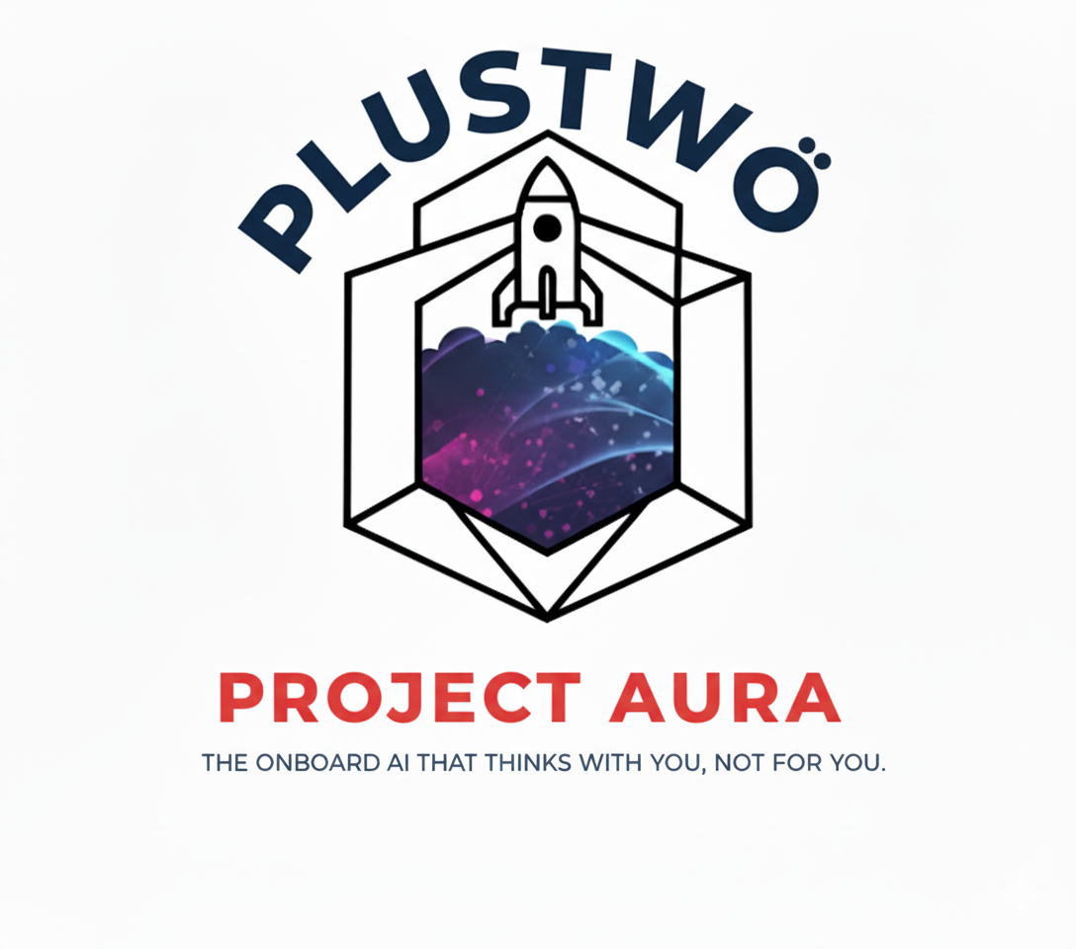

Leader, Lead Researcher, Overall Idea Lead, AI Videos, Business Lead, AI Translation Lead: Dave Seah Yong Sheng, NTU AeroEng

AI Videos, AI Brain Lead, Orchestrator Lead, Security Lead, Digital Twin: Darren Seah Yong Liang, NCS Software Engineer

Astroskin Data Lead, Human Factors Lead, Bio Lead: Timothy Isaac Chua, SUTD Engineering Product Development

3D Simulation Lead, ACE Module Lead, Presentations Lead: Wong Jia Sheng Timothy, SIT Robotics Systems Engineering

Mentored By:

Don Balanzat, Founder and XR & AI Systems Developer, ChaoticCuriosity.

Sanjeev Sharma, Principal Dynamics Engineer, SpaceX (Retired).

Matthew Chew, Nuclear Competency & Strategy Lead, HY.

Submission Date: 12/10/2025

## Table of Contents:

Project AURA: Autonomous Unified Reality Augmentation 1

Table of Contents: 1

List of Tables: 3

List of Abbreviations: 3

AI Usage Declaration: 3

Abstract 4

1.0 The New Imperative: Redefining Astronaut Autonomy Beyond Earth's Reach 5

1.1 The Tyranny of Distance: Communication Latency as a Foundational Constraint 6

1.2 A Synthesis of Stressors: The Physiological, Cognitive, and Operational Burdens of Deep Space 6

1.3 The AURA Thesis: From Human-in-the-Loop to a True Human-AI Symbiosis 7

1.4 Objectives of the Study 8

2.0 AURA, An Integrated, Autonomous Ecosystem 9

Can help make this flow chart to single column? 12

2.4 The Tactile Interface: Haptic Feedback Patch 21

2.5 The Human Sensor: The Biometric Monitoring System 22

2.6 The AURA Adaptive Contingency Engineering (ACE) Module 30

2.7 The VPK Subsystem: An Embodied Kinematic Model 33

3.0 Power, Security, Legality, and Human Factors 35

3.1 AURA Power Architecture: A Sovereign Radioisotope Power System 35

3.2 Security by Design: The Imperative of a Sovereign, Air-Gapped AI 38

3.3 Human-in-Command: HCI Principles for High-Stakes Environments 39

3.4 Legal framework of data collection in space 40

4.0 Project Management and Viability 41

4.4 Go-to-Market Execution & Investment Requirements 41

4.5 Conclusion 41

5.0 Conclusion: A New Symbiosis for Human Exploration 41

6.0 References 41

7.0 Appendices 41

Figure 1: Bruch membrane opening (BMO) and height. [4] 9

Figure 2: Percent frequency of low scores during flight and post-flight [5] 9

Figure 3: Flowchart of AURA [In Depth Flowchart in Appendix 1] 12

Figure 4: Full flow of Orchestration of Workflow on Space and Earth 14

Figure 5: Earth Side Orchestrator 15

Figure 6: Space Side Orchestrator 15

Figure 7: Full Flow Overview for AR/XR Portion 16

Figure 8: Concept Heads Up Display Layout for Outside Station [AI-Image], more Features in the Video 16

Figure 9: Procedural Overlay in 3D Simulation (Fire Extinguisher) 18

Figure 10: Procedural Overlay in 3D Simulation (Bolts and Vents) 18

Figure 11: Evan G1 Example for AURA (Yo why cant i remove the thing on the right, should be link) 11] 2

Figure 12: META Glasses [11] 2

Figure 13: How NeRF works [13] 3

Figure 14: Example with Quest 3 & Vision Pro [Demo in Video] [14] 3

Figure 15: Architecture of WhisperLiveKit [15] 2

Figure 16: Live Translation Flowchart [Appendix XXX] 3

Figure 17: Schematic of Haptic Patch [16] 1

Figure 18: Flowchart of Biometric Monitoring System 1

Figure 19: Astroskin [28] 3

Figure 20: Backend Dataflow and Simulation [Code in Appendix xxx] 3

Figure 21: ACE Module Concept [AI-Image] 7

Figure 22: Market opportunity visualization showing AURA's addressable segments within major terrestrial markets 5

Figure 23: Revenue and investment progression showing AURA's path from healthcare pilots to market dominance 5

## List of Tables:

Table 1: Mapping Astronaut Operational Needs to AURA System Capabilities 10

Table 2: Sensors Involved 2

Table 3: Individual Vital Sign Alert Thresholds 3

Table 4: Data Fusion Alert Criteria 4

Table 5: Potential Development with AlphaGenome Compared to Current Capabilities 5

Table 6: Comparative Properties of Space-Grade AM Polymers 7

Table 7: AURA System Power Budget Across Operational Modes 4

Table 8: Comparative Analysis of RPS Technologies for a Wearable AURA System 5

Table 9: Risk Mitigation Strategy 8

Table 11: AURA Component Stack and Technology Readiness Level (TRL) Assessment 2

Table 12: 6-Month Proof-of-Concept Budget breakdown (Proof of concept phase) 3

Table 13: AURA vs. The State-of-the-Art. 8

## List of Abbreviations:

## AI Usage Declaration:

|  |  |
| --- | --- |
| Which generative AI tool did you use (name and version)? | <https://chatgpt.com/?model=gpt-4o>  <https://chatgpt.com/?model=o1-preview>  <https://chatgpt.com/?model=o1-mini>  <https://claude.ai/>  <https://gemini.google.com/app?hl=en_GB>  <https://3d.hunyuan.tencent.com/>  <https://openrouter.ai/>  <https://ollama.com/>  <https://zoo.dev/design-studio> |
| What prompt did you provide? |  |
| What did you use the tool for? |  |
| How have you used or changed the generative AI’s output? |  |

# Abstract

The imminent era of long-duration human space missions necessitates a paradigm shift in astronaut operational support, driven by the foundational constraint of communication latency with Earth. This report establishes the context for next-generation exploration, identifying the physiological, psychological, and operational stressors that will limit unassisted crew performance. In response, this document introduces Project AURA (Augmented Unified Reality Assistant), an integrated systems engineering solution designed to maximize astronaut autonomy and mission effectiveness.

The AURA ecosystem is architected as a human-AI symbiote, centred on a sovereign, on-suit AI Brain. This cognitive core, running a space-domain fine-tuned Large Language Model (LLM) with agents utilizing a specialised Small Language Model (SLM), ensures secure, instantaneous decision-making independent of any Earth-based connection. The system's capabilities are delivered through synergistic subsystems: an interactive Augmented Reality (AR) sensory overlay for procedural and navigational guidance; haptic feedback patch for tactile interaction; a non-invasive biometric monitoring network for real-time state assessment; and an Adaptive Contingency Engineering (ACE) module for on-demand, generative design and fabrication of components.

The central thesis of this project is that by holistically augmenting an astronaut's perception, cognition, and execution capabilities through a secure, closed-loop architecture, AURA transforms the human operator into a safer, more efficient, and truly autonomous agent, ensuring mission success where Earth-based support is critically delayed or entirely unavailable.

# 1.0 The New Imperative: Redefining Astronaut Autonomy Beyond Earth's Reach

Contemporary human space exploration faces its most significant transformation since the Apollo era. Strategic initiatives such as NASA's Artemis program, development of the Lunar Gateway, and long-range plans for crewed Mars missions signal a definitive shift from short-duration sorties in Low Earth Orbit (LEO) to sustained, long-duration presence in deep space. This new era is characterized not merely by greater distances, but by an operational paradigm shift from Earth-dependent to semi-autonomous and ultimately autonomous crew operations. This transition is driven by an immutable physical constraint: the finite speed of light [1].

## 1.1 The Tyranny of Distance: Communication Latency as a Foundational Constraint

The electromagnetic spectrum, encompassing radio waves used for space communications, travels at approximately 299,792,458 meters per second in vacuum. This fundamental physical constant creates increasingly significant delays as spacecraft venture beyond Earth's immediate vicinity. For lunar missions like Artemis, one-way communication delays range from 1.3 seconds at minimum distance to approximately 14 seconds during maximum lunar libration. The actual operational latency during Artemis missions is anticipated to reach up to 10 seconds one-way due to signal processing requirements inherent in modern digital communication protocols, unlike the analogue systems used during Apollo.

Mars missions present dramatically more challenging conditions. One-way communication delays vary from 3.5 minutes at closest approach (opposition) to over 22 minutes at maximum separation (superior conjunction) [2]. During Mars conjunction events, when the planet passes behind the Sun relative to Earth, communication blackouts can extend for three weeks. These delays make real-time Earth-based mission control impossible, necessitating unprecedented levels of crew autonomy.

This communication lag represents not an engineering challenge to be solved but a fundamental constraint mandating unparalleled levels of crew self-reliance. The escalating need for autonomy coincides precisely with increased mission complexity. Astronauts must operate advanced spacecraft, deploy novel scientific instruments, and navigate hazardous planetary surfaces without the immediate safety net of Mission Control. The cognitive load previously distributed across large, specialised ground teams becomes compressed onto small, isolated flight crews, creating unprecedented risks of cognitive overload, human error, and catastrophic mission failure.

Project AURA emerges as a direct response to this challenge, designed to serve as a cognitive and perceptual force multiplier for the autonomous astronaut.

## 1.2 A Synthesis of Stressors: The Physiological, Cognitive, and Operational Burdens of Deep Space

To design an effective augmentation system, one must first conduct a comprehensive analysis of the human operator's limitations and needs within the extreme environment of space. The challenges are multifaceted, spanning the physiological, psychological, and operational domains.

**Physiological Stressors:** The human body, adapted to Earth's gravity, experiences a chain of negative effects in its absence. Long-duration microgravity exposure induces well-documented physiological deconditioning including cardiovascular degradation, orthostatic intolerance, significant bone density loss, and skeletal muscle atrophy. Post-flight orthostatic intolerance affects approximately 83% of astronauts returning from long-duration missions, compared to only 5% of the unexposed general population. Concurrently, sensory-motor functions undergo alteration, with approximately 70% of astronauts experiencing Spaceflight Associated Neuro-ocular Syndrome (SANS) [3] [4], which can permanently impair vision. These physiological changes represent immediate performance degraders that reduce physical capacity, impair motor control, and increase injury risk during physically demanding tasks.

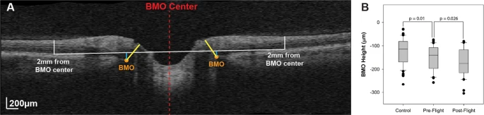

Figure : Bruch membrane opening (BMO) and height. [4]

**Psychological and Cognitive Strain:** Deep space missions impose formidable psychological stressors through extreme isolation, confinement in hostile environments, disrupted circadian rhythms, and relentless high-stakes workloads. Astronauts report "space fog" or "space stupids", phenomena characterised by attention lapses, confusion, and short-term memory deficits. Recent comprehensive studies of 25 astronauts on six-month ISS missions documented measurable declines in processing speed, visual working memory, and sustained attention, with some effects persisting 30 days post-mission [5]. These cognitive degradations directly impact astronauts' ability to manage complex procedures, diagnose system anomalies, and respond effectively to emergencies.

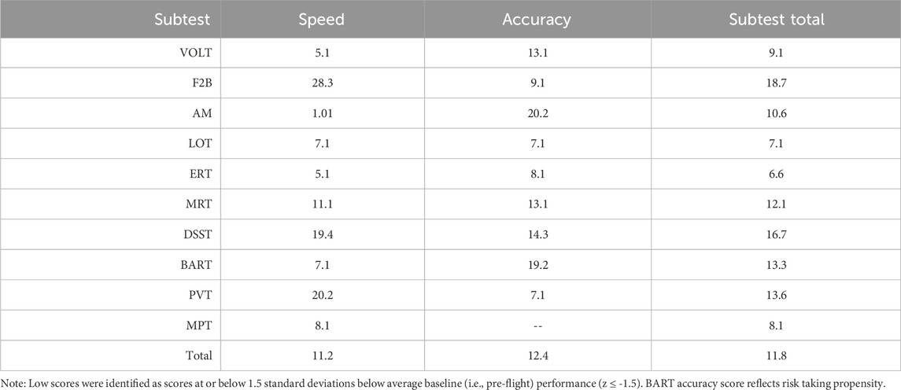 Figure 2: Percent frequency of low scores during flight and post-flight [5]

**The Unique Perils of Extravehicular Activity (EVA):** EVAs represent the apex of operational risk and human performance demands in spaceflight. Beyond exposure to vacuum, extreme temperature fluctuations, and micrometeoroid/orbital debris threats, the spacesuit itself imposes severe operational limitations. Pressurized, multi-layered patch significantly reduces dexterity and tactile sensation, increasing the time, physical effort, and metabolic load required for manual tasks. This sensory deprivation and mechanical clumsiness elevate risks of tool mishandling and equipment damage. The combination of high physical workload, cognitive pressure, and sensory impairment makes EVA a prime domain for augmentation through advanced human-computer interfaces

## 1.3 The AURA Thesis: From Human-in-the-Loop to a True Human-AI Symbiosis

Project AURA represents a holistic, integrated solution engineered to address the synthesised needs of deep space astronauts. The system transcends current techniques of disparate, disconnected tools, tablets for procedures, separate biometric harnesses for health data, periodic voice links for support, creating instead a unified, intelligent ecosystem that envelops the astronaut.

The core thesis of AURA: By creating a secure, closed-loop system that continuously monitors the astronaut's physiological and psychological state (biometrics), environmental and equipment conditions (external sensors, telemetry), the astronaut's physical movements and capabilities (kinematics), and overarching mission context (procedures, timelines), then providing precisely curated, interactive information through synergistic visual (AR) and tactile (haptic) channels, AURA transitions from passive information provider to active, intelligent partner. The innovation lies not in any single component, but in the intelligent synthesis of their functions and profound context-awareness, enabling delivery of the right information, in the right way, at the exact moment needed, fostering true human-AI symbiosis.

Table : Mapping Astronaut Operational Needs to AURA System Capabilities

|  |  |  |
| --- | --- | --- |
| **Identified Astronaut Need/Challenge** | **Causal Factors** | **AURA System Mitigation** |
| High cognitive load during complex EVA repairs | Divided attention between task and procedure documents; communication latency with ground support; difficulty identifying small components; sensory deprivation from patch | AR/XR Display: Overlays contextual, step-by-step instructions and schematics directly onto hardware. AI Brain: Provides predictive fault diagnosis and highlights relevant components. Haptic Patch: Guide tool placement and confirm correct component interaction |
| Risk of catastrophic error during emergencies (e.g., depressurisation) | Disorientation; stress-induced cognitive tunnelling; difficulty locating safety equipment and egress paths; time pressure | AR/XR Display: Minimalist emergency UI with bold, unambiguous pathfinding overlays. AI Brain: Instantly calculates time-to-criticality and optimal egress routes. Haptic Patch: Deliver urgent, non-visual warning vibrations. Biometrics: Monitors for hypoxia/panic and can alert teammates |
| Physiological and psychological degradation on long-duration missions | Isolation; confinement; high workload; lack of Earthly stimuli; disrupted circadian rhythms | Biometrics: Continuous, non-invasive monitoring of vitals and inferred stress/fatigue levels. AI Brain: Detects early signs of cognitive decline or excessive stress. AR/XR Display: Can provide personalised interventions, such as calming visual stimuli or guided breathing exercises |
| Inefficiency and fatigue during manual EVA tasks | Reduced dexterity and tactility from pressurized patch; high physical exertion required to overcome suit pressure; difficulty judging forces in microgravity | Haptic Patch: Provide tactile feedback to substitute for lost sensation, warning of excessive force or hazardous surfaces. AI Brain: Monitors metabolic rate via biometrics and can suggest pacing adjustments to conserve energy and oxygen |
| Inability to rely on real-time ground support | Signal transmission delay of up to 48 minutes round-trip for Mars missions | AI Brain: Serves as an onboard, sovereign expert system, containing the knowledge base of an entire ground support team. AR/XR Display & Haptic Patch: Act as the communication medium for this onboard expert, providing immediate guidance and feedback |

## 1.4 Objectives of the Study

The aim of this research is to develop and validate Project AURA, an AI-driven, on-suit support system designed to maximise astronaut autonomy and mission effectiveness in deep space environments. This system is engineered to function independently of Earth-based control, augmenting the astronaut's cognitive and physical capabilities through a symbiotic human-AI architecture. The findings aim to establish a new operational paradigm for crewed missions where significant communication latency is a foundational constraint.

### 1.4.1 Primary Objectives

* To develop a real-time, autonomous on-suit AI agent.
* Design and validate a system capable of a complete sense–decide–act loop for time-critical hazard response, ensuring zero dependence on ground support during communication delays of up to 22 minutes.
* To enhance astronaut performance and safety during Extravehicular Activity (EVA).
* Leverage an Augmented Reality (AR) interface and haptic feedback to reduce EVA procedure time and errors. The system will deliver high-precision AR overlays and detect suit or equipment anomalies within 5 seconds of onset with ≥ 95% sensitivity.
* To create a biometric-adaptive interface that mitigates cognitive load.
* Integrate non-invasive biometric sensors to continuously monitor the astronaut's physiological state. The system will be designed to detect stress thresholds and automatically simplify the user interface within 2 seconds to reduce error rates during high-workload tasks.

**To establish an on-demand, adaptive engineering capability.**

* Create and validate an Adaptive Contingency Engineering (ACE) pipeline that enables the on-demand 3D scanning, generative design, and fabrication of critical components. This system will be designed to manufacture parts in under 120 minutes, meeting mission-critical safety tolerances while prioritizing the use of local planetary materials (e.g., regolith) and recycled hardware to fundamentally reduce logistical dependency on Earth.

### 1.4.2 Secondary Objectives

**To implement an Earth-side digital twin for asynchronous analysis and model refinement.**

* Stand up a ground-based digital twin that utilises compressed daily data uplinks from the AURA suit. This will be used to analyse crew and AI performance, with the goal of transmitting validated model updates to improve in-flight system effectiveness.

**To quantify and validate the human-factors benefits of the AURA system.**

* Use established metrics, including NASA-TLX and kinematic modelling, to assess the system's impact. The research will target a ≥ 15% reduction in perceived astronaut workload during complex procedures and validate the accuracy of its ergonomic risk-prevention models.

**To characterise next-generation components for deep space applications.**

* Investigate and verify the performance of materials critical to the AURA ecosystem, including space-grade polymers for the ACE module and novel beta voltaic power sources, documenting their performance characteristics for mission integration.

# 2.0 AURA, An Integrated, Autonomous Ecosystem

The architecture of Project AURA is conceived as a human-centric ecosystem, where technology serves as a seamless extension of the astronaut's own senses and cognitive abilities. It is a closed-loop system designed for real-time data fusion, intelligent processing, and intuitive, multimodal feedback. The system's design is founded on principles of modularity, allowing individual subsystems to be upgraded as technology advances, and scalability, ensuring its applicability from single-person EVAs to multi-crew surface habitat operations.

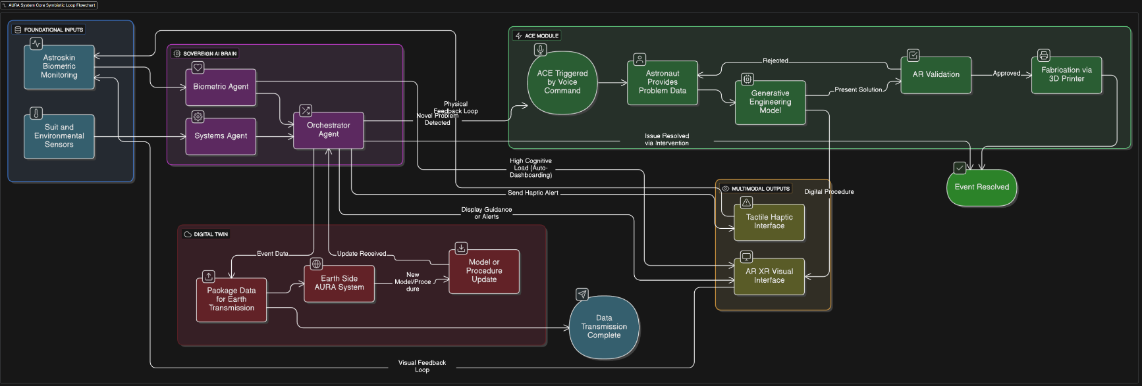

Figure : Flowchart of AURA [In Depth Flowchart in Appendix 4]

### 2.1 Conceptual Architecture: The Closed-Loop Symbiotic Framework

At the heart of the AURA architecture is the astronaut, who is simultaneously the user of the system and its most critical data source. The system is composed of four primary, interconnected subsystems: The Central AI Brain, the Biometric Monitoring System, the AR/XR Display, and the Haptic Feedback Patch. The flow of information creates a continuous, adaptive loop. Data from the biometric system, suit sensors, and external vehicle telemetry are fed into the Central AI Brain. This AI core fuses and interprets the data to build a comprehensive context model of the user's state and their current task. Based on this model, the AI generates and pushes specific, relevant information to the XR Display and Haptic Patch. The astronaut perceives this information, acts upon it, and their subsequent actions and physiological responses are captured by the sensors, thus closing the loop and providing new data for the AI to process. This architecture transforms the interaction from a simple command-response model to a dynamic, symbiotic partnership between the human and the AI agent.

### 2.2 The Cognitive Core: AURA's Sovereign AI Brain

AMD XQR Versal AI Core Equivalent: This type of consumer PC build would commonly feature:

* A Ryzen 9 7950X or Ryzen 7 7800X CPU (16 or 8 cores) for scalar tasks,
* An AMD Radeon RX 7900 XT or NVIDIA RTX 4090 GPU for GPU-intensive AI inferencing,
* 64GB or more of system memory with unified and dedicated GPU memory to handle large models,
* Running frameworks like TensorFlow, PyTorch to benchmark LLM inference.

The architectural heart of the AI Brain is a purpose-built, space-qualified heterogeneous computing platform. The flight-ready system is designed around the AMD XQR Versal AI Core, an Adaptive Compute Acceleration Platform (ACAP) engineered for reliable operation in the harsh radiation environment of deep space. For the ground-based proof-of-concept development and demonstration, the system will be implemented on the NVIDIA RTX 5090, which serves as a functional proxy for developing and validating the AI software stack.

This selection is a deliberate design choice to ensure absolute security, minimal latency, and unwavering reliability. The Versal ACAP integrates multiple distinct processing engines, including dual-core Arm Cortex-A72 application processors, dual-core Arm Cortex-R5F real-time processors, a vast fabric of adaptable FPGA logic, and a dedicated array of 400 AI Engines, onto a single, radiation-tolerant die. This allows the AURA system to execute different parts of its workload on the most efficient possible engine: high-level logic and LLM orchestration on the Arm cores, custom sensor data fusion in the adaptable logic, and intensive neural network inference on the power-efficient AI Engines. This multi-agent system is managed by a local orchestration framework, with specialised AI agents coordinated by a central orchestrator. The AI Brain is fine-tuned on a curated dataset comprising NASA's operational knowledge, transforming it into a domain expert. Critically, the Versal architecture is radiation-tolerant by design, incorporating features like Error Detection and Correction (EDAC) on all major memories to prevent the Silent Data Corruption that would be catastrophic in a commercial chip. It is qualified to withstand a Total Ionizing Dose of 100 krad(Si) and is immune to destructive Single-Event Latch-up (SEL), ensuring the system's integrity over a multi-year deep space mission. This flight-qualified hardware provides the trustworthy and resilient foundation required for a true human-AI symbiosis.

**Domain-Specific Fine-Tuning:** A general-purpose LLM, even a powerful one, lacks the specialised knowledge required for high-stakes space operations. To address this, a base model, such as a computationally efficient 7-billion parameter model, is fine-tuned on a curated, domain-specific dataset. This dataset comprises the entire corpus of NASA's operational knowledge: technical manuals, mission procedures, spacecraft and habitat schematics, historical mission logs with failure analyses, and anonymized physiological and performance data from previous spaceflights. This process transforms the LLM into a domain expert that comprehends the unique terminology, procedures, and logic of space operations, drastically improving its accuracy and relevance while reducing the risk of generating vague or incorrect information ("hallucinations").

**Onboard Agent Orchestration:**

Onboard Agent Orchestration: The AI Brain is not a monolithic entity, but a multi-agent system (MAS) managed by a local orchestration framework, inspired by robust architectures like LangChain and CrewAI. This system is built on an agent-to-agent architecture, allowing a team of specialised AI agents to collaborate, delegate tasks, and share information directly. The complex interactions and overall workflow between these agents are managed and executed by N8n, which serves as the central orchestration engine. This distributed and collaborative approach enhances modularity, resilience, and allows for parallel processing of complex tasks. Key agents include:

* **Procedural Agent:** Manages the retrieval and step-by-step delivery of task instructions.
* **Biometric Agent:** Continuously analyses incoming physiological data to infer stress, fatigue, and cognitive load.
* **Systems Agent:** Monitors telemetry from the spacesuit, tools, and surrounding equipment for anomalies.
* **Navigation Agent:** Responsible for real-time spatial mapping, localisation, and pathfinding for the AR guidance module.
* **Orchestrator Agent:** The "team lead" that receives user queries or system triggers, decomposes the complex task, delegates sub-tasks to the appropriate specialised agents, and synthesizes their outputs into a coherent response for the astronaut.
* **Orchestrator Agent:** The "team lead" that receives user queries or system triggers, decomposes the complex task, delegates sub-tasks to the appropriate specialised agents, and synthesizes their outputs into a coherent response for the astronaut.

### 2.2.1 Large Language Model (LLM)

The AURA system relies on a specialised, computationally efficient Large Language Model (LLM) as its primary knowledge and reasoning engine.

Our selected base model (Mistral 7B) is fine-tuned on a curated, domain-specific dataset. This dataset will encompass the entire corpus of NASA's operational knowledge, including technical manuals, mission procedures, schematics, and historical mission logs. Due to the lack of training material/data, we have proceeded to train it on publicly available datasets and a specially curated table of criticality distinctions. This process transforms the general-purpose LLM into a domain expert that comprehends the unique logic and terminology of space operations, drastically improving accuracy and reducing the risk of generating inaccurate information (hallucinations).

The fine-tuned LLM facilitates Explainable AI (XAI, not to be confused it x.ai), allowing the astronaut to engage in natural language dialogue with the system to build trust and prevent automation bias. For example, the astronaut can ask "AURA, why?" when an alternative procedural step is suggested, and the system provides a reasoned, context-aware explanation based on telemetry data.

We train the model by employing Low-Rank Adaptation (LoRA), a Parameter-Efficient Fine-Tuning (PEFT) technique, often combined with Quantization (QLoRA). This methodology significantly reduces the computational burden by freezing the model's 7 billion original parameters and training only small adapter layers injected into the attention layers, achieving efficiency (over 99% reduction in trainable parameters) suitable for rapid development and deployment onto the onboard hardware. The training process successfully converted the raw data into a consistent instruction-following format, enabling the LLM to produce structured outputs containing a criticality rating and detailed reasoning.

### 2.2.2 The AI Brain

The AI Brain is architected as a purpose-built, space-qualified heterogeneous computing platform. It acts as an onboard, sovereign expert system containing the collective knowledge of an entire ground support team, providing immediate guidance and feedback.

The flight-ready core is designed around the AMD XQR Versal AI Core (ACAP). This Adaptive Compute Acceleration Platform is radiation-tolerant by design, qualified to withstand a Total Ionizing Dose (TID) of 100 krad(Si), and is immune to Single-Event Latch-up (SEL).

The Versal architecture integrates dual-core Arm Cortex-A72 processors (for high-level logic and LLM orchestration), adaptable FPGA logic (for custom sensor data fusion), and a dedicated array of 400 AI Engines (for intensive neural network inference). This allows the system to execute different parts of its workload on the most efficient engine possible.

The AI Brain serves as the central intelligent processing component of a continuous, closed-loop system. It fuses and interprets data from the Biometric Monitoring System, suit sensors, and external telemetry to build a comprehensive context model of the astronaut's state and task.

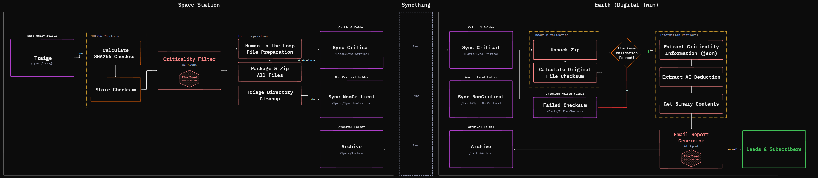

Figure : Full flow of Orchestration of Workflow on Space and Earth

### 

### 2.2.3 The Digital Twin

The AURA system includes an Earth-side digital twin designed to support asynchronous analysis and continuous model refinement.

The digital twin is a ground-based replica that utilizes data uploaded from the AURA suit to analyse crew and AI performance over time. This asynchronous review is crucial because communication latency precludes real-time intervention from Earth-based Mission Control.

The onboard system orchestrates a scheduled workflow to gather logs into an optimized data packet. Data transfer is managed by Syncthing, a peer-to-peer tool chosen for its security and resilience, ensuring end-to-end TLS encryption and the ability to resume interrupted transfers over unstable deep space links.

The primary goal of the twin is to develop and validate model updates. When new AI models are developed on Earth, they are cryptographically signed with a private key before transmission. The onboard system then verifies this signature using a public key, ensuring the integrity and authenticity of the AI Brain's software is maintained before deployment.

### 2.2.4 Orchestrator

The AI Brain employs a Multi-Agent System (MAS) where specialised AI agents collaborate to manage tasks. This collaboration is managed by a local orchestration framework.

The complex interactions and overall workflow between the specialised agents are managed and executed by N8n, which serves as the central orchestration engine within the Sovereign AI Brain. The selection of N8n provides an intuitive visual workflow builder for technician debugging and seamless human-in-the-loop integration.

The Orchestrator Agent acts as the "team lead". It receives user queries or system triggers, decomposes the complex task, delegates sub-tasks to the appropriate specialised agents (e.g., Procedural Agent, Biometric Agent, Systems Agent, Navigation Agent), and synthesizes their outputs into a coherent response for the astronaut.

This orchestration, including the use of n8n, is designed to run entirely locally on the suit-integrated hardware as part of the "Cognitive Airgap" architecture, ensuring functionality and security during communication blackouts.

The most critical factor is the need for an **air-gapped, sovereign AI system**. Project AURA must function autonomously during communication blackouts lasting minutes to weeks, making zero dependence on Earth-based connections an absolute necessity.

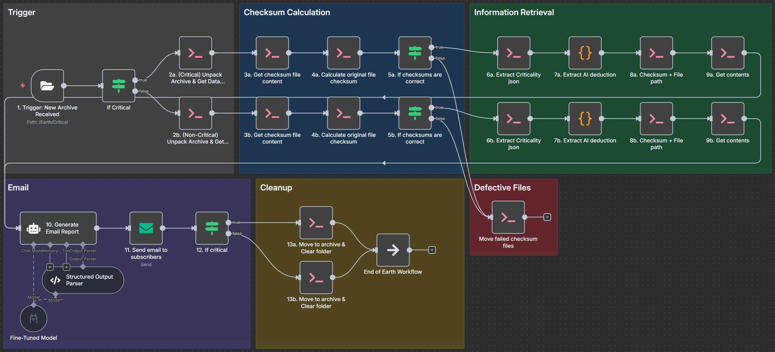

Figure : Earth Side Orchestrator

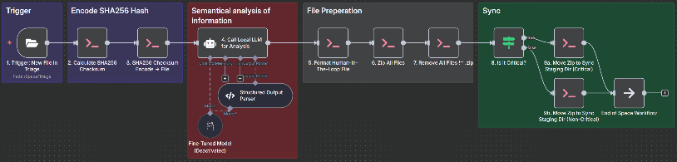

Figure : Space Side Orchestrator

### 2.2.5 Selection and Benchmarks

The selection of core hardware and the AI system's performance is governed by the need for autonomous, low-latency, and radiation-tolerant operation in deep space.

The selection of the AMD XQR Versal AI Core (ACAP) is driven by the imperative for absolute security, minimal latency, and unwavering reliability. Its radiation-hardened design ensures computational integrity over a multi-year deep space mission. This platform is specifically required to execute a complete sense–decide–act loop for time-critical hazard response, functioning independently of ground support.

The orchestration tool N8n was selected to provide an accessible and visual structure for managing the multi-agent system, supporting the operational doctrine of the astronaut or technician having the ability to debug and modify AI workflows (Workflow Transparency).

The AI core and its software stack are benchmarked against stringent time-criticality requirements:

The fine-tuned LLM running on the system achieves an 182ms inference latency.

The system achieves a 97.5% criticality rating accuracy.

The most demanding benchmark is the real-time hazard avoidance loop, requiring the latency from initial sensor reading to multimodal output (haptic/AR) to be under 100 milliseconds (faster than human reflex time).

The system is engineered to detect suit or equipment anomalies within 5 seconds with a sensitivity of ≥ 95%.

**Tooling selection**

As an open-source workflow automation platform, n8n supports mandatory **self-hosting**. This allows the entire orchestration framework (including the multi-agent system) to run locally on the suit-integrated hardware (the AMD XQR Versal AI Core). This creates the **"Cognitive Airgap"** architecture, guaranteeing core functionality and **data sovereignty**.

In contrast, **Google Opal** is a fully managed cloud service, tightly integrated with Google Cloud, which directly violates the requirement for local, air-gapped operation due to compliance concerns and data control issues within a managed environment. **OpenAI AgentKit** is similarly designed for deployment via standard API models or cloud solutions like ChatGPT Enterprise, making it reliant on external network connectivity that is non-existent in deep space operations.

### 2.3 The Sensory Overlay: The AR/XR Visual Interface

The Augmented Reality/Extended Reality (AR/XR) visual interface constitutes the primary output layer of the AURA ecosystem. It serves as a cognitive and perceptual augmentation layer, translating the complex analyses of the AI Brain and the dense data streams from the suit’s sensor network into intuitive, actionable information projected directly into the astronaut's field of view. The design of this interface is not merely a matter of displaying data; it is governed by a rigorous philosophy of Human Factors Engineering (HFE) and Human-Centred Design (HCD) tailored for high-stakes environments. Drawing from the decades of design evolution in military and civil aviation cockpits, the AURA interface is architected from first principles to enhance, rather than overload, the astronaut's finite cognitive and perceptual capabilities.

In the extreme operational context of an Extravehicular Activity (EVA), characterised by high physical workload, significant cognitive stress, sensory deprivation imposed by the spacesuit, and the catastrophic potential of error, the interface must be more than a passive display. It must function as an active, intelligent partner. As research from the German Aerospace Centre (DLR) and the European Space Agency (ESA) highlights, navigating the lunar surface presents profound challenges, from extreme lighting conditions to impaired spatial orientation, necessitating a high degree of astronaut autonomy [6]. Core HFE principles are therefore of high importance: the design must be user-centred, compatible with human physical and cognitive limitations, tolerant of error, and prioritise simplicity and clarity over an abundance of features. The following feature sets are engineered to embody this philosophy.

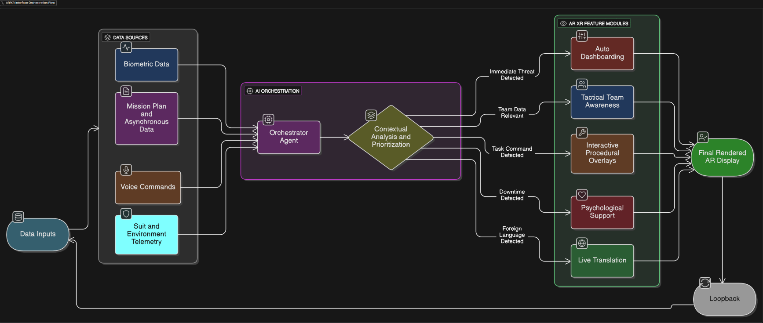

Figure : Full Flow Overview for AR/XR Portion

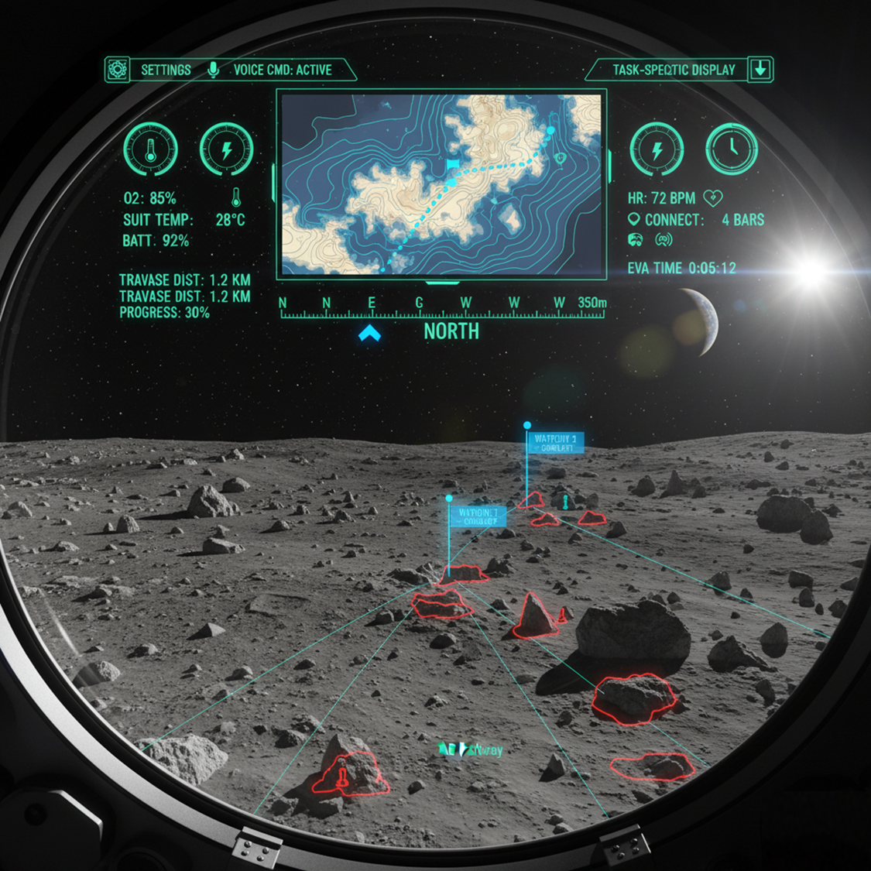

Figure : Concept Heads Up Display Layout for Outside Station [AI-Image], more Features in the Video

### 2.3.1 The Principle of "Auto-Dashboarding": A Biometric-Adaptive UI

The foundational principle of the AURA interface is "Auto-Dashboarding," a dynamic system that actively curates the information presented to the astronaut based on their real-time physiological and cognitive state. This moves beyond a static Head-Up Display (HUD) to create a truly biometric-adaptive interface.

The system directly links the Biometric Monitoring System (Section 2.5) to the AR display via the Sovereign AI Brain (Section 2.2). The Biometric Agent continuously analyses the incoming data stream, calculating key indicators of workload, such as Heart Rate Variability (HRV) to infer stress levels. When these metrics cross a predefined threshold, the Orchestrator Agent automatically triggers a change in the visual interface. For example, if the AI detects biometric markers of rapidly increasing stress during a complex manual task, it can autonomously intervene by:

1. Simplifying the UI: Fading out non-essential information like mission timers or secondary telemetry.
2. Enhancing Focus: Subtly increasing the prominence of task-critical procedural overlays.
3. Reducing Notifications: Temporarily suppressing non-critical alerts or communications.

This closed-loop feedback mechanism, where the astronaut's own body drives the behaviour of their interface, is designed to mitigate cognitive overload and reduce the probability of error during high-stakes moments.

### 2.3.2 Tactical Team Awareness Display (TTAD)

To combat the poor situational awareness and impaired spatial orientation documented since the Apollo era, the TTAD provides the astronaut with real-time, at-a-glance information about their EVA partners and immediate surroundings. This feature is broken into two key components:

Live Vitals & Suit Telemetry: Each crew member in the EVA team has a persistent but non-intrusive HUD element showing the vital signs and key suit telemetry (e.g., O2 level, battery) of their partner(s). The display is directly linked to the AURA alert system, with its border colour dynamically changing from green (Nominal) to yellow (Warning) or red (Critical), allowing for instant, non-verbal status checks [7] [8] [9].

Crew Proximity Minimap: A compact, 3D radar-style minimap provides a "god's-eye" view of the local area, showing the relative position and orientation of other crew members, rovers, and key mission objectives. The technical foundation for this component is a local Indoor Positioning System (IPS) that utilises a network of Ultra-Wideband (UWB) anchors on suits and equipment to achieve centimetre-level positioning accuracy, even in GPS-denied environments like the lunar south pole [10].

### 2.3.3 Feature: Interactive Procedural Overlays

A core function of the AURA AR interface is to provide real-time, interactive guidance for complex manual tasks, from routine maintenance to emergency repairs facilitated by the Adaptive Contingency Engineering (ACE) module (Section 2.6). This feature moves beyond simple checklists by superimposing digital instructions directly onto the physical environment, reducing the cognitive load associated with mentally mapping 2D instructions to a 3D workspace. As identified in studies on lunar HUDs, a key challenge for astronauts is the high mental workload and potential for error when dividing attention between instructions and the task itself [6]. This system is designed to mitigate that risk by creating an intuitive, voice-driven workflow that seamlessly integrates navigation and action.

The operational flow for a procedural task, such as replacing a faulty filter, demonstrates the synergy between the underlying computer vision technologies and the AI agent architecture:

1. **Voice Interpretation:** The astronaut initiates the task with a natural language command (e.g., "AURA, guide me through replacing the CO2 filter"). The command is captured by microphones and processed locally by the AI Brain's fine-tuned Large Language Model (LLM), which uses its advanced Natural Language Processing (NLP) capabilities to understand the user's intent.
2. **Agent Orchestration:** The Orchestrator Agent receives the interpreted request and tasks the relevant specialised agents. The Procedural Agent retrieves the multi-step procedure from its knowledge base, while the Navigation Agent queries the system's inventory database to locate the necessary spare filter and required tools.
3. **Navigational Guidance:** The Navigation Agent calculates the most efficient path to the required items and renders this path in the astronaut's AR display as intuitive visual cues, such as floating arrows or a highlighted pathway on the floor.
4. **Procedural Overlay:** Once at the worksite, the Procedural Agent takes over. It leverages a sophisticated fusion of computer vision technologies, Simultaneous Localisation and Mapping (SLAM) to understand the workspace geometry and 3D Object Recognition to identify specific components, to anchor step-by-step instructions directly onto the hardware. It renders a sequence of 3D holographic overlays, highlighting the specific panel to be opened, the bolts to be turned (including torque specifications), and the correct orientation for the new filter. This turns complex 2D manual instructions into intuitive 3D visual guidance.

Additionally, when the Systems Agent independently detects an anomaly, such as a micro-fracture or a pressure leak, this system will immediately place a conspicuous, pulsing red marker on the physical location of the damage. This instantly guides the astronaut's visual attention to the problem area, bypassing the need for manual searching and diagnosis.

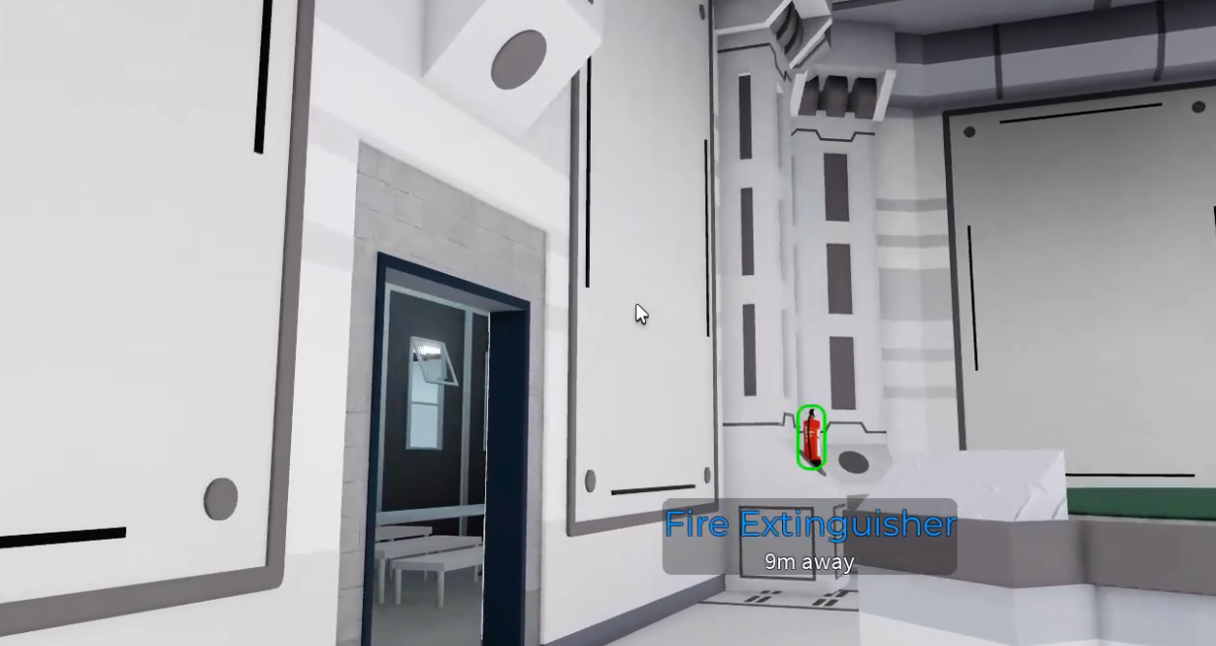

Figure : Procedural Overlay in 3D Simulation (Fire Extinguisher)

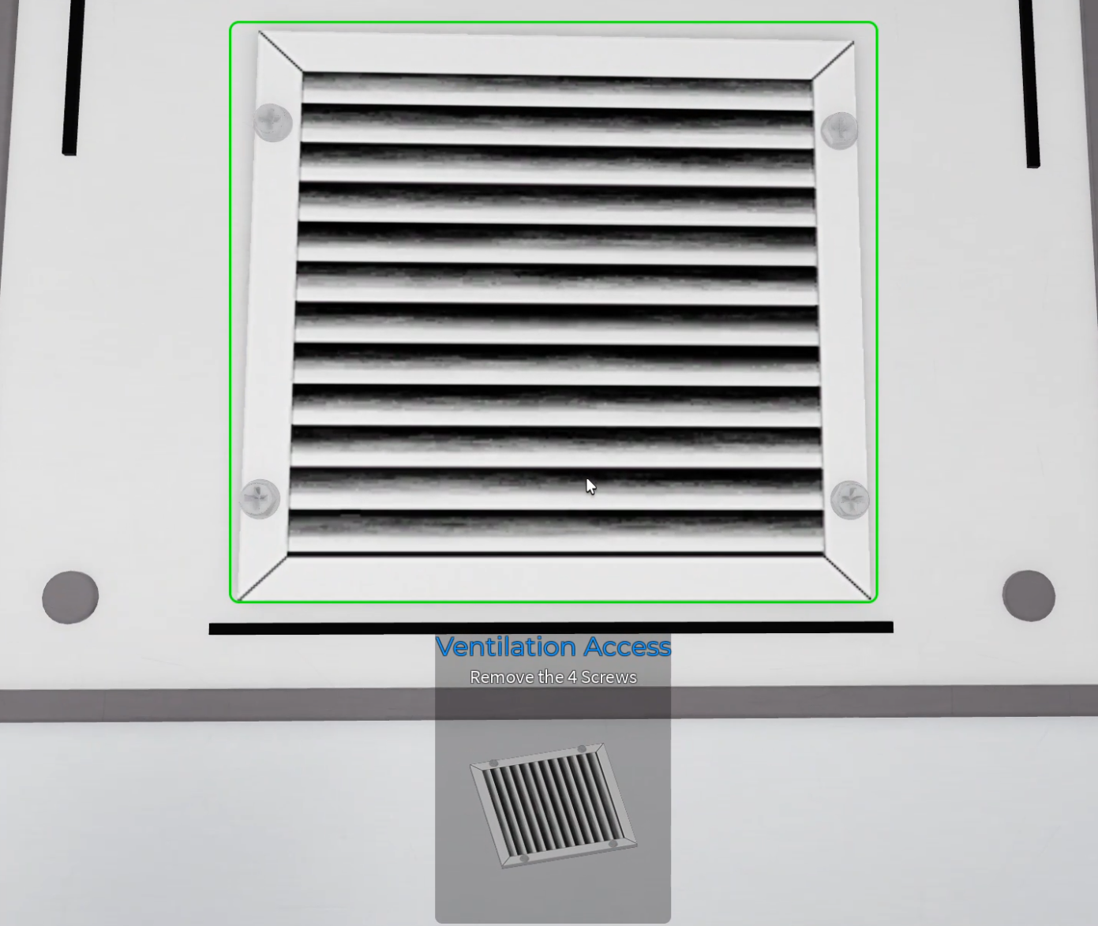

Figure : Procedural Overlay in 3D Simulation (Bolts and Vents)

**Hardware Platforms:** This dual-use system is deployed on two distinct hardware platforms. For intra-vehicular activity (IVA), it utilizes industrial-grade, lightweight AR smart glasses designed for comfort and extended wear, like the META AI Glasses (Figure 8). For extra-vehicular activity (EVA), the display components are integrated directly into the helmet visor, functioning as a true heads-up display (HUD). This integration builds upon extensive research by NASA in developing HMDs for EVA training and future spacesuits, ensuring the display is unobtrusive, readable, and robust enough for the rigors of space.

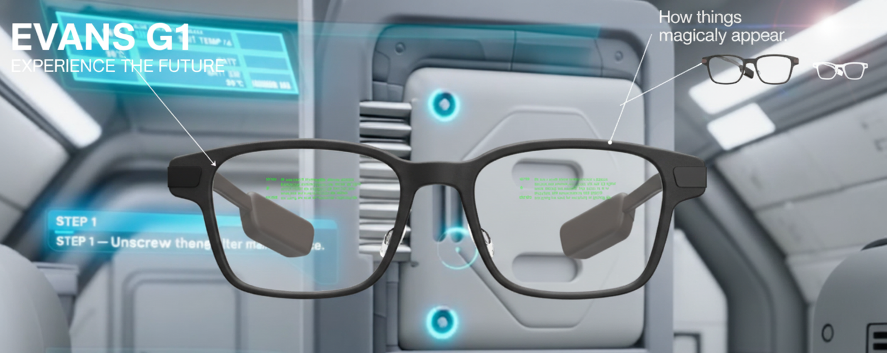

Figure : Evan G1 Example for AURA (Yo why cant i remove the thing on the right, should be [link](https://www.evenrealities.com/g1)) [11]

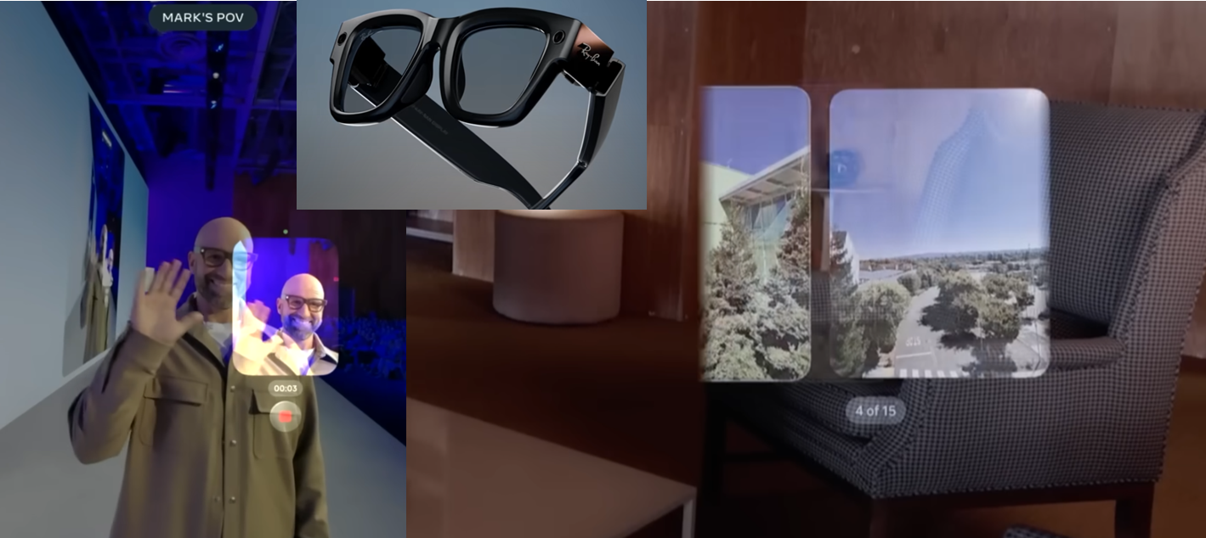

Figure : META Glasses [11]

### 2.3.4 Feature: Psychological Support & Asynchronous Communication

While operational performance is paramount, the long-term viability of deep space missions is critically dependent on the psychological well-being of the crew. As extensive research on behavioural health in space has shown, the synergistic effects of isolation, confinement, and extreme distance from Earth create significant psychological stressors that can directly impact crew cohesion and mission success [12]. To proactively mitigate these documented risks, the AURA system incorporates a feature designed to provide a vital sense of connection and combat the profound psychological challenge of separation from family.

This system moves beyond traditional 2D video calls to leverage the immersive power of AR, creating a tangible sense of presence that is critical for astronaut well-being.

* **Volumetric "AR-Mail":** This system allows astronauts to receive and play back pre-recorded volumetric videos from their families. An astronaut can "place" a life-sized, three-dimensional holographic recording of a loved one within their personal quarters, creating an immersive and comforting experience that a flat screen cannot replicate. The technical feasibility of this data-intensive feature, even with significant bandwidth constraints, is made possible by recent breakthroughs in **Neural Radiance Fields (NeRF)**. This technique allows for the representation of complex 3D scenes in a highly compressed format, enabling the transmission of volumetric recordings that can be rendered with high fidelity on the suit's local hardware.

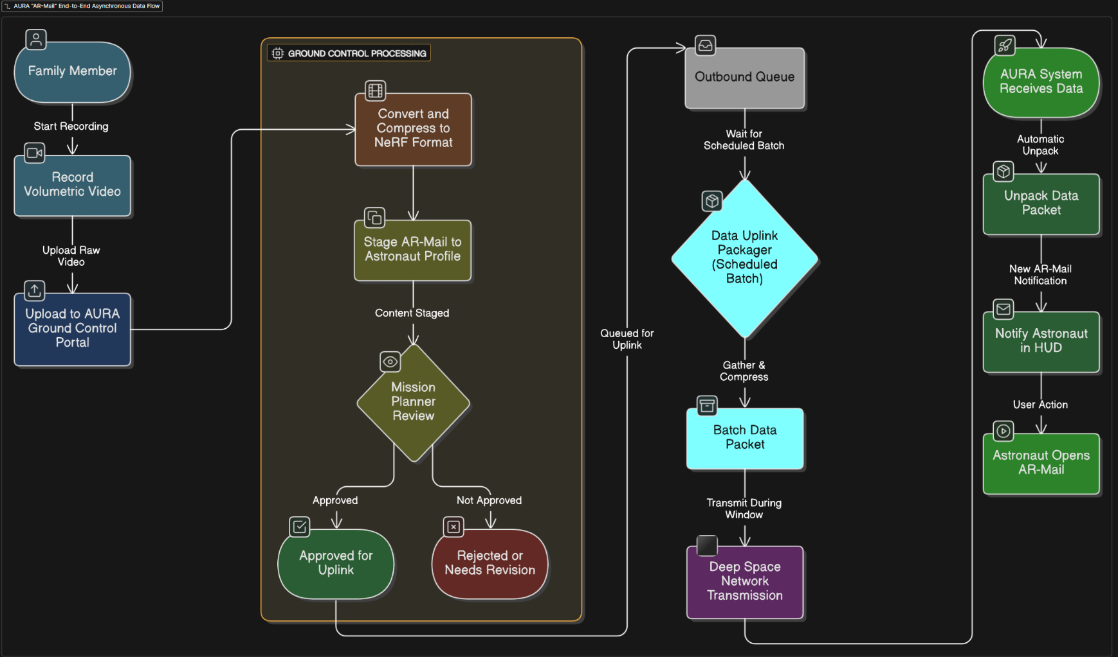

Figure : Flowchart for AR-Mail

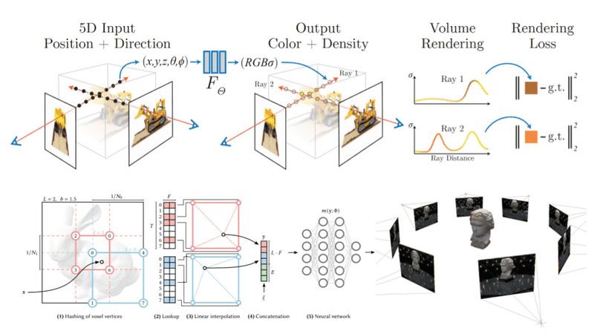

Figure : How NeRF works [13]

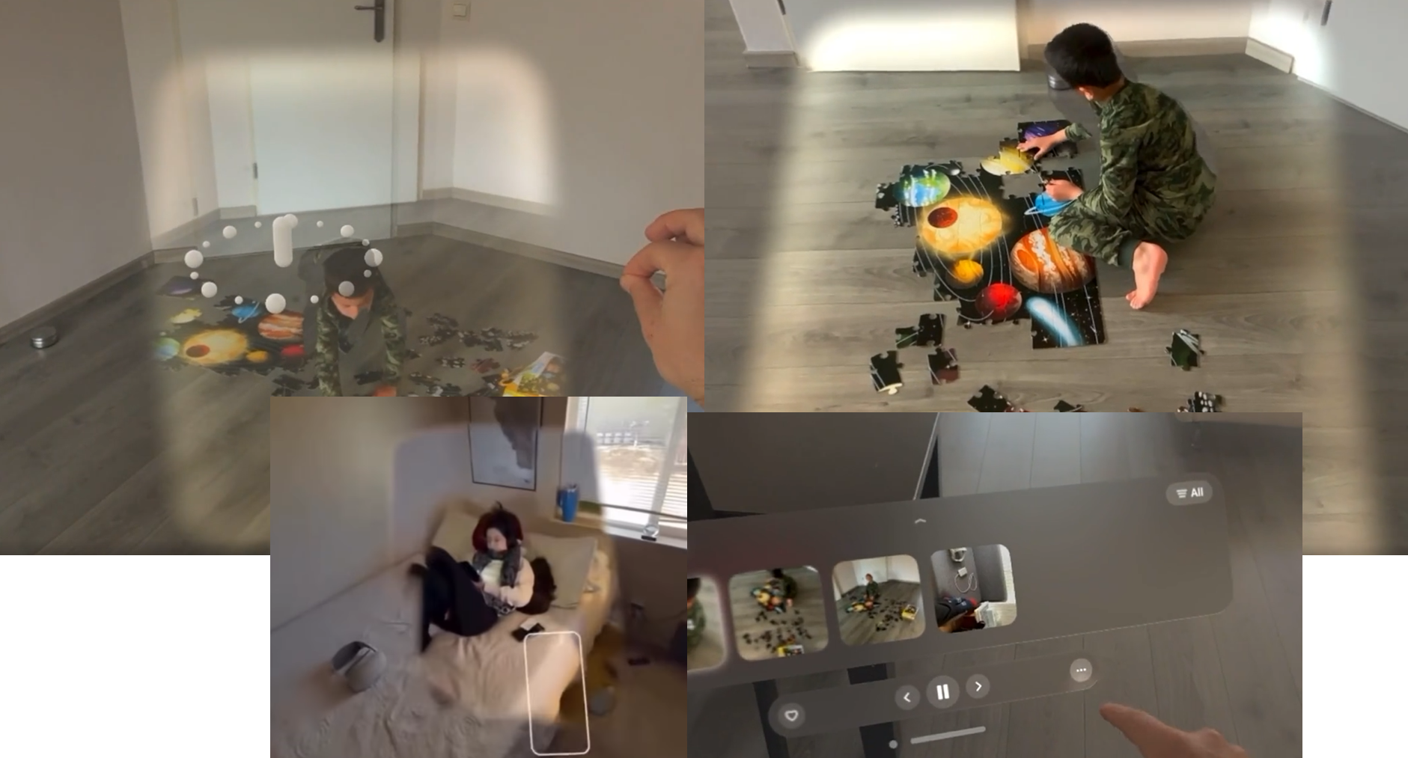

Figure : Example with Quest 3 & Vision Pro [Demo in Video] [13]

### 2.3.5 Feature: Real-Time Language Translation Subsystem

To maintain clear, unambiguous communication in multi-national crews, particularly during high-workload or emergency operations, the AURA system includes an integrated, on-device translation module that operates fully offline. This is essential for deep-space missions where communication latency and intermittent links preclude reliance on ground services. The core capability is a live subtitling system within the HUD. When a crew member speaks, the AI Brain runs on-device automatic speech recognition (ASR) followed by neural machine translation (NMT), overlaying unobtrusive subtitles in the listener’s HUD with clear speaker attribution. The design incorporates human-factors research, ensuring subtitles are placed to minimise occlusion and use confidence indicators (e.g., underlining low-confidence words) to mitigate the risk of misinterpretation during critical operations.

The technical foundation for this feature relies on a pipeline of compact, edge-deployable neural models that ensure privacy and low latency by performing all processing locally. The ASR front-end is built on high-noise-tolerant engines (e.g., Whisper variants) to provide robust transcription in the noisy EVA environment. This transcription is then fed into a state-of-the-art NMT model. The architecture is designed to support foundational models like Meta's SeamlessM4T v2, which enables speech-to-text translation across a wide array of languages [14]. This approach mirrors the privacy-first, local-processing philosophy of projects like Mozilla’s Bergamot, ensuring that critical communication is handled securely and autonomously within the suit's ecosystem.

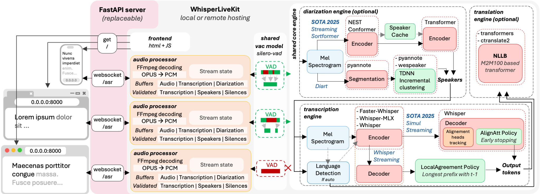

Figure : Architecture of WhisperLiveKit [14]

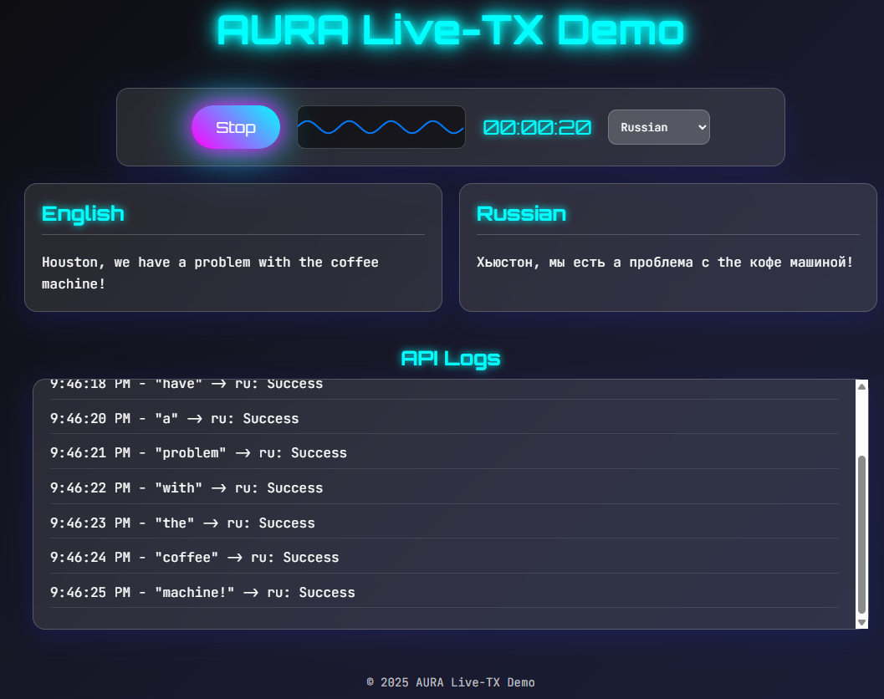

Figure : Live Translation Demo [Appendix 3]

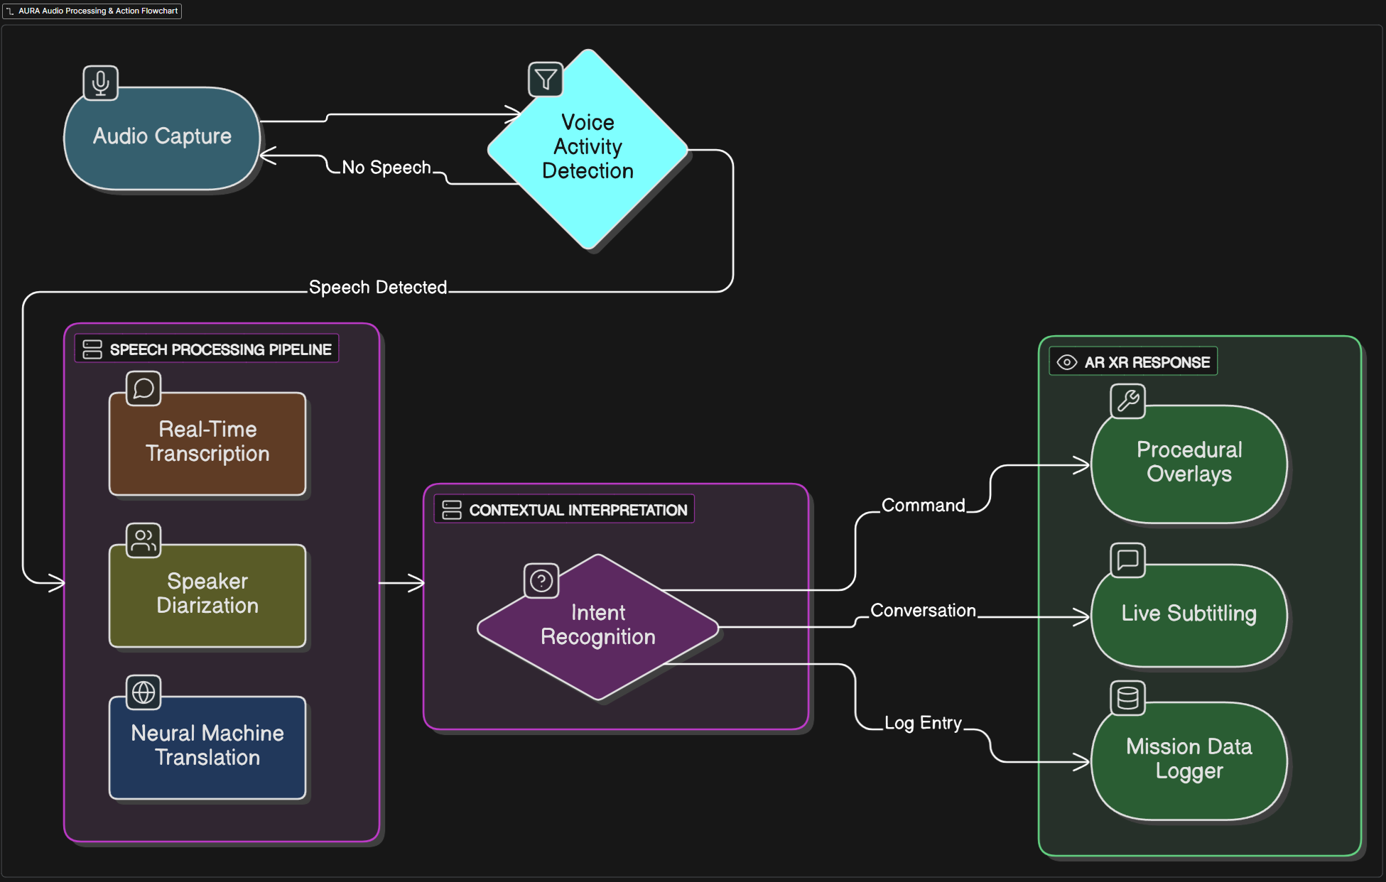

Figure : Live Translation Flowchart [Appendix 2]

## 2.4 The Tactile Interface: Haptic Feedback Patch

To overcome the profound sensory deprivation and loss of dexterity caused by pressurized EVA Patch, the AURA system incorporates a haptic feedback subsystem integrated into the Patch. This subsystem provides a non-visual, intuitive communication channel, using the sense of touch to convey information, guidance, and warnings. The functionality of the Haptic Patch can be categorized into three primary modes: Guidance (subtle vibrations to guide the hand), Warnings (strong alerts for hazards like hot surfaces), and Data "Feeling" (translating abstract data like fluid pressure into tactile sensations). While the Technology Readiness Level (TRL) for advanced force-feedback Patch is low, a phased approach starting with robust vibrotactile motors is proposed to deliver core functionality early in the development cycle.

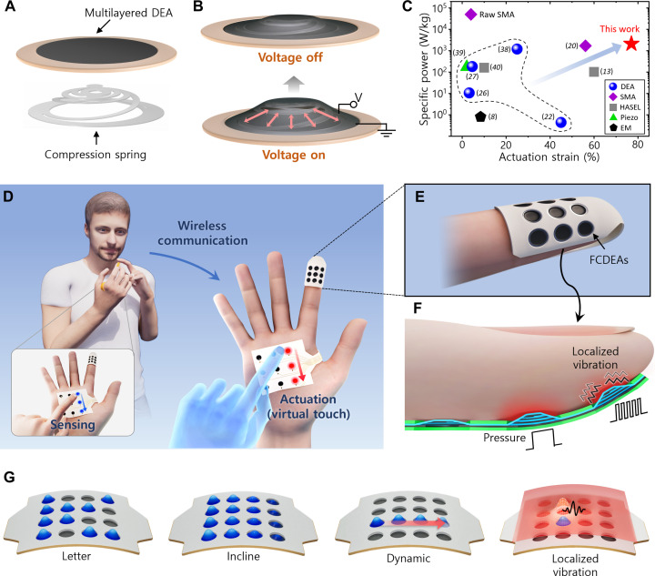

Figure : Schematic of Haptic Patch [13]

## 2.5 The Human Sensor: The Biometric Monitoring System

The Biometric Monitoring System is the foundational input layer of the AURA ecosystem, providing the AI Brain with a continuous, high-fidelity data stream on the astronaut's physiological status. The proposed hardware is the flight-proven Bio-Monitor (Astroskin) system, already operational on the ISS (TRL 9). This system continuously measures key vital signs, including heart rate, blood pressure, and respiration rate. The AI Brain utilizes this raw data to infer not only physical state (e.g., exertion level) but also psychological state by analysing patterns in heart rate variability (HRV) to estimate stress or fatigue. This transforms the astronaut from a passive subject being monitored into an active participant whose own body directs the behaviour and responsiveness of the AURA system. This real-time awareness of the human's state enables the AURA system's closed-loop feedback mechanism, where the astronaut's own body drives the behaviour of their interface. For example, if the AI detects biometric markers of rapidly increasing stress, it can autonomously intervene by simplifying the AR display or providing calming audio prompts.

The space environment, particularly microgravity, causes profound and systemic deconditioning of the human body because it removes the constant load and stimuli that Earth's gravity provides. The Biometric Monitoring System is essential to understand and mitigate these changes. [15]

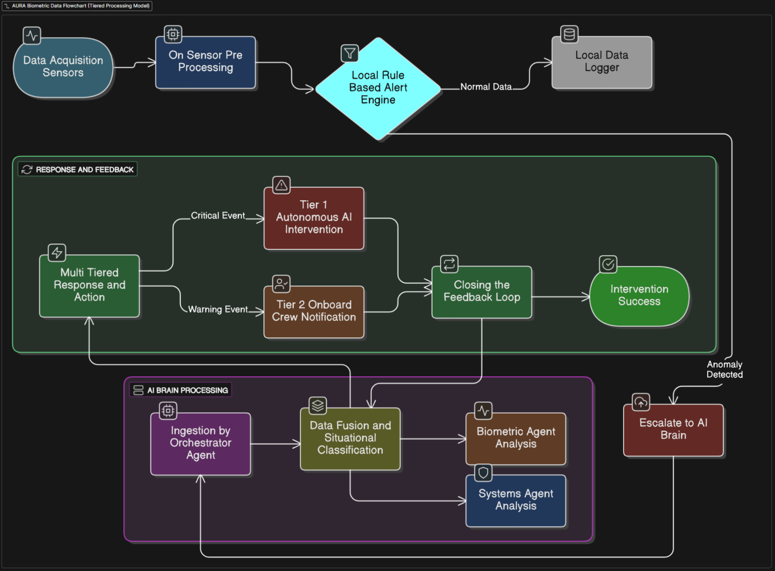

Figure : Flowchart of Biometric Monitoring System

### 2.5.1 Physiological Systems

#### 2.5.1.1 Musculoskeletal System

The deterioration of the musculoskeletal system in microgravity is a well-documented and primary concern for long-duration spaceflight. On Earth, gravity provides a constant mechanical load that is essential for maintaining bone remodelling and muscle mass. In the weightless environment of space, this critical loading stimulus is absent, leading to a state of disuse atrophy. This results in a rapid and significant loss of muscle mass, particularly in anti-gravity muscles like those in the back and legs, and a concomitant decrease in bone mineral density due to increased bone resorption outpacing bone formation. The consequences are severe, with astronauts experiencing muscle mass losses of up to 20% in short-duration missions and a reduction in bone density of 1-2% per month, dramatically increasing the risk of fractures both during missions and upon return to gravity. Furthermore, the loss of strength and proprioception poses a significant risk to mission success during critical physical tasks [16] [17]. Continuous biometric monitoring of activity levels via systems like Astroskin is therefore necessary to ensure adherence to personalised, exercise regimens, which are the primary countermeasure to mitigate this condition.

#### 2.5.1.2 Cardiovascular System

The cardiovascular system undergoes significant deconditioning in microgravity, primarily driven by the loss of hydrostatic pressure gradients. The absence of gravity causes a fluid shift of approximately 2 litres of blood and other fluids from the lower extremities to the thorax and head [18]. This central fluid volume expansion is initially perceived by the body as a state of fluid overload, triggering a compensatory response that includes reduced thirst, increased urination, and a subsequent overall reduction in plasma volume. Over time, the heart, no longer required to work against gravity to pump blood upward, begins to atrophy and lose muscle mass. This combination of reduced blood volume and a deconditioned heart leads to a decreased aerobic capacity and, most notably, orthostatic intolerance, an inability to maintain blood pressure upon standing after return to Earth, causing dizziness and fainting. There is also evidence of an increased incidence of cardiac arrhythmias and orthostatic intolerance in space [19]. Biometric monitoring through tools like a 3-lead ECG, blood pressure cuff, and oximeter is essential to track these adaptations in real-time, guide fluid intake and exercise, and identify potentially dangerous arrhythmias before they become critical.

#### 2.5.1.3 Sensory and Balance Systems (Neurovestibular)

The human sensory and balance systems, which evolved to function under Earth's gravity, are profoundly disrupted by microgravity. The primary issue lies within the vestibular system of the inner ear. The otolith organs, which normally sense linear acceleration and gravity, become unloaded and provide conflicting signals to the brain in conjunction with visual and proprioceptive inputs. This sensory conflict triggers Space Motion Sickness (SMS) in approximately 70% of astronauts during the first 72 hours of flight, characterized by nausea, vomiting, and dizziness, which can impair performance [20]. Furthermore, many astronauts experience structural changes to the eye and optic nerve, a condition known as Spaceflight-Associated Neuro-ocular Syndrome (SANS), which can lead to long-term vision changes [21]. Spatial disorientation is a persistent risk, especially during complex manual manoeuvres or emergency egress. Monitoring patterns in heart rate variability and respiration can provide the AI with proxies for stress and disorientation, allowing it to simplify displays and reduce cognitive load during critical periods to maintain operational safety.

#### 2.5.1.4 Immune System

Spaceflight presents a multifaceted challenge to the human immune system, leading to a state of dysregulation and suppression. Astronauts are exposed to a combination of stressors known to impair immune function, including microgravity, cosmic radiation, psychological stress, altered sleep cycles, and changes in gut microbiota [22]. Research has shown that key immune cells, such as T-cells and Natural Killer (NK) cells, exhibit reduced function and reactivity, effectively weakening the body's ability to combat pathogens and monitor for cancerous cells. This suppressed state leads to the reactivation of latent viruses (e.g., Epstein-Barr virus, varicella-zoster virus) and increases susceptibility to new infections [23]. Monitoring core body temperature via the Astroskin's sensors provides a critical early warning sign of fever and active infection [24]. When correlated with other biometric data like elevated heart or respiration rate, it allows for the early isolation of unwell crew members and the prompt initiation of medical countermeasures to prevent an outbreak that would be catastrophic in a confined space habitat.

### 2.5.2 Autonomous Healthcare for Deep Space

While the current system on the ISS relies on near-instantaneous communication with Earth, this is untenable for deep space missions, which introduces challenges such as communication delays and bandwidth limitations. This makes real-time guidance from flight surgeons on Earth impossible during a medical emergency. Therefore, the Biometric Monitoring System is an essential data collection and analysis system for a new, autonomous model of healthcare in space. This critical constraint necessitates a fundamental advancement from Earth-dependent monitoring to an autonomous, onboard health management system. The Biometric Monitoring System provides the essential, continuous data stream that enables this new model, serving as the foundational input layer of the AURA ecosystem.

In this evolved model, AURA continuously analyses the biometric data stream to first autonomously rectify minor anomalies itself, such as mitigating stress by simplifying AR displays. For more complex issues, it alerts the onboard Crew Medical Officer (CMO) and provides AI-guided support using enhanced medical checklists and procedural guidance. Concurrently, the system transmits the data to Earth, where flight surgeons can devise a treatment plan asynchronously; this plan is then uploaded to the station for the CMO and astronaut to execute with AURA's assistance, thus creating a resilient healthcare model that functions effectively despite the communication constraints of deep space.

### 2.5.3 Integrated Biometric Monitoring in AURA

The integrated Biometric Monitoring and AURA AI system solves the critical challenges of deep-space healthcare by transitioning from a reactive, Earth-dependent model to a proactive, autonomous, and predictive one. It directly enables three core solutions: personalized countermeasures, proactive medical intervention, and preparation for Earth reconditioning. The system's effectiveness is rooted in its intelligent, hierarchical response protocol, designed to function seamlessly despite communication delays.

When an anomaly is detected, the onboard AI first attempts to resolve it autonomously through non-invasive interventions, such as modifying the user's interface to reduce stress. For more complex issues, it immediately alerts the onboard CMO, providing AI-guided checklists and procedural support to enable independent diagnosis and treatment without waiting for Earth. Concurrently, all data is transmitted to Earth, where flight surgeons and medical teams can asynchronously analyse the situation and upload a comprehensive treatment plan for the crew to execute. This closed loop ensures continuous care.

### 2.5.4 Astroskin - Data Collection

The foundational hardware that enables the Biometric Monitoring System is the flight-proven Bio-Monitor (Astroskin), an advanced, non-invasive biomonitoring platform developed by the Canadian Space Agency (CSA) [25]. This system moves health monitoring from sporadic, bulky equipment checks to a seamless, integrated part of the astronaut's daily routine.

Astronauts are outfitted with a custom-fitted uniform that incorporates the Astroskin's two key components: a lightweight Astroskin shirt (often called a "smart shirt") and an Astroskin headband. This garment-based approach ensures continuous and comfortable wear without interfering with daily tasks or exercise regimens. As a proven, operational technology on the International Space Station (ISS), Astroskin has achieved a Technology Readiness Level (TRL) of 9, the highest possible rating, meaning it is a flight-proven system ready for long-duration missions [25].

The Astroskin platform provides state-of-the-art, real-time biometric monitoring, capable of continuously tracking an astronaut's five core vital signs for periods of up to 48 hours per session. By serving as the primary data-gathering layer, it feeds a continuous, high-fidelity stream of physiological information into the AURA system for analysis, forming the critical first link in the autonomous closed-loop health monitoring system. The five core vital signs include the heart monitor, breath monitor, oximeter, blood pressure, and skin temperature. In addition to these five vital signs, the Astroskin system incorporates a 3-axis accelerometer to track activity level [26].

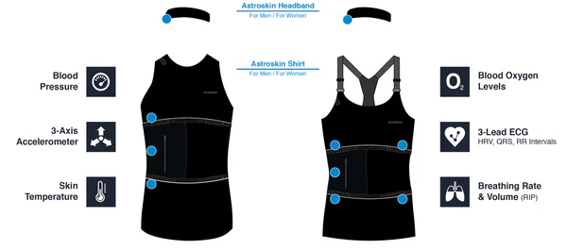

Figure : Astroskin [26]

#### 2.5.4.1 Heart Monitor

This sensor provides electrocardiogram (ECG) data, tracking heart rate and, crucially, heart rate variability (HRV). For a healthy astronaut at rest, a typical baseline heart rate falls between 60-100 beats per minute, with HRV being highly individual. It is the primary tool for detecting cardiac arrhythmias and assessing overall cardiovascular workload. The AURA system utilizes this data for the early detection of heart conditions and, through analysis of HRV patterns, to estimate psychological and physiological states such as stress, cognitive load, and fatigue. This enables proactive interventions to prevent injuries and manage astronaut well-being.

#### 2.5.4.2 Breath Monitor

The breath monitor measures respiration rate and volume. This data is essential for observing lung capacity and efficiency, reflecting the respiratory system's proficiency in delivering oxygen to the body and removing carbon dioxide. Typical baselines are between 12-20 breaths per minute at rest. Deviations from baseline, such as an increased rate (tachypnoea), can serve as an early indicator of fever or infection, while a decreased rate (bradypnea) may suggest issues like sleep apnoea. Furthermore, respiration rate is a key biomarker for stress monitoring.

#### 2.5.4.3 Oximeter

The pulse oximeter measures peripheral blood oxygen saturation (SpO2%), a measurement of the percentage of oxygen-saturated haemoglobin in the blood, with a normal resting baseline ranging from 95% to 100%. This metric is intrinsically linked to respiration rate and is used to verify that cells and tissues are receiving sufficient oxygen. Low blood oxygen levels (hypoxia) can indicate underlying respiratory conditions, such as pneumonia. While related to respiration data, it provides critical redundancy and confirmation for diagnosing cardiopulmonary issues.

#### 2.5.4.4 Blood Pressure Monitor

The system provides continuous, non-invasive blood pressure monitoring. While chronic hypertension or hypotension are unlikely in pre-screened astronauts, transient changes are highly significant. Baseline systolic pressure typically ranges from 90-120 mmHg and diastolic from 60-80 mmHg. These fluctuations can be indicative of acute states such as stress, anxiety, physical exertion, or dehydration. Furthermore, transient hypertension can be an early indicator of cardiovascular deconditioning and may signal a higher likelihood of developing sustained cardiovascular issues.

#### 2.5.4.5 Skin Temperature Monitor

Continuous skin temperature monitoring is used to infer core body temperature trends, which has typical resting values between 32-35°C depending on location. This data is a vital sign for detecting the onset of fever and infection. Beyond this, it provides insights into thermoregulation, heat stress, arousal states, and mental and physical performance. It is also a valuable component in analysing and tracking the astronaut's sleep cycle and overall circadian rhythm.

#### 2.5.4.6 Activity Level

The integrated accelerometer quantitatively measures an astronaut's activity level, movement, and orientation. This data is crucial for ensuring adherence to personalized exercise regimes, which are the primary countermeasure against microgravity-induced muscle atrophy and bone density loss. It provides an objective measure of physical activity to ensure crew members are receiving adequate exercise to maintain physiological health.

#### 2.5.5 Data Fusion & Analysis

The true power of the Astroskin system is realized through data fusion, a process where the AURA AI cross-references multiple data streams to derive sophisticated insights into astronaut health that are not apparent from any single metric alone. The accuracy of these inferences is not based on each sensor working in isolation, but on the convergence of evidence from multiple, redundant data streams. This approach allows the AI to cross-validate signals, filter out noise and motion artifacts, and make highly confident probabilistic assessments of the astronaut's physiological state. The system's reliability is further enhanced by first establishing a personalized baseline for each crew member, ensuring that alerts are based on significant deviations from their own norm rather than a generic population average.

The following table outlines the primary sensor combinations, their applications, and the physiological rationale that makes them accurate and reliable:

Table : Sensors Involved

|  |  |  |
| --- | --- | --- |
| **Sensor Combination** | **Primary Application** | **Physiological Rationale & Reliability** |
| **Respiration Rate + Oximeter** | Lung efficiency & potential conditions (e.g., hypoxia) | **High Clinical Correlation**. Respiration rate (RR) measures effort, while oximetry (SpO2) measures effectiveness. A high RR with low SpO2 is a strong, clinically validated indicator of respiratory distress (e.g., hypoxia, pneumonia), making this combination reliable for validation and redundancy. |
| **HR + Respiration + BP + Skin Temp** | Comprehensive stress and anxiety estimation | **High Reliability for ANS Activation**. This combination is a proxy for the sympathetic nervous system. A coordinated rise in all four signals is a classic "fight-or-flight" response to stress. A change in one could be noise; a change in all four is a highly reliable indicator of psychological or physiological strain. |
| **HR + Respiration** | Cardiovascular condition monitoring | **Strong Correlation for Effort**. HR and RR rise in a predictable correlation during exercise. A deviation from this correlation (e.g., a disproportionately high HR) can reliably indicate cardiovascular deconditioning, fatigue, or the onset of illness. |
| **All Sensors + Accelerometer** | Quantification of activity level and exertion | **Essential for Contextual Accuracy.** The accelerometer provides critical context. It distinguishes between a high heart rate from exercise versus one from medical distress, preventing false alarms and ensuring vitals are interpreted against the backdrop of physical activity. |
| **BR + Oximeter + Skin Temp + Sleep Logs** | Sleep quality analysis | **High Validity for Sleep Tracking**. This is a well-established method (actigraphy). Movement (accelerometer), respiration, HRV (sleep stages), skin temperature (circadian rhythm), and oximetry (apnoea events) together provide an accurate, non-invasive picture of sleep architecture and quality. |
| **Skin Temp + HR + Respiration Rate** | Early detection of infections and febrile states | **Highly Predictive for Infection**. The body's febrile response is coordinated: a rising temperature set-point triggers increases in HR and RR to support metabolism. A simultaneous, unexplained upward trend in all three is a highly reliable and early signature of the body mounting an immune response, often before subjective awareness of illness. |

This multi-sensor fusion approach makes the AURA ecosystem far more accurate and reliable than the sum of its parts, forming the basis for its proactive and predictive health management capabilities.

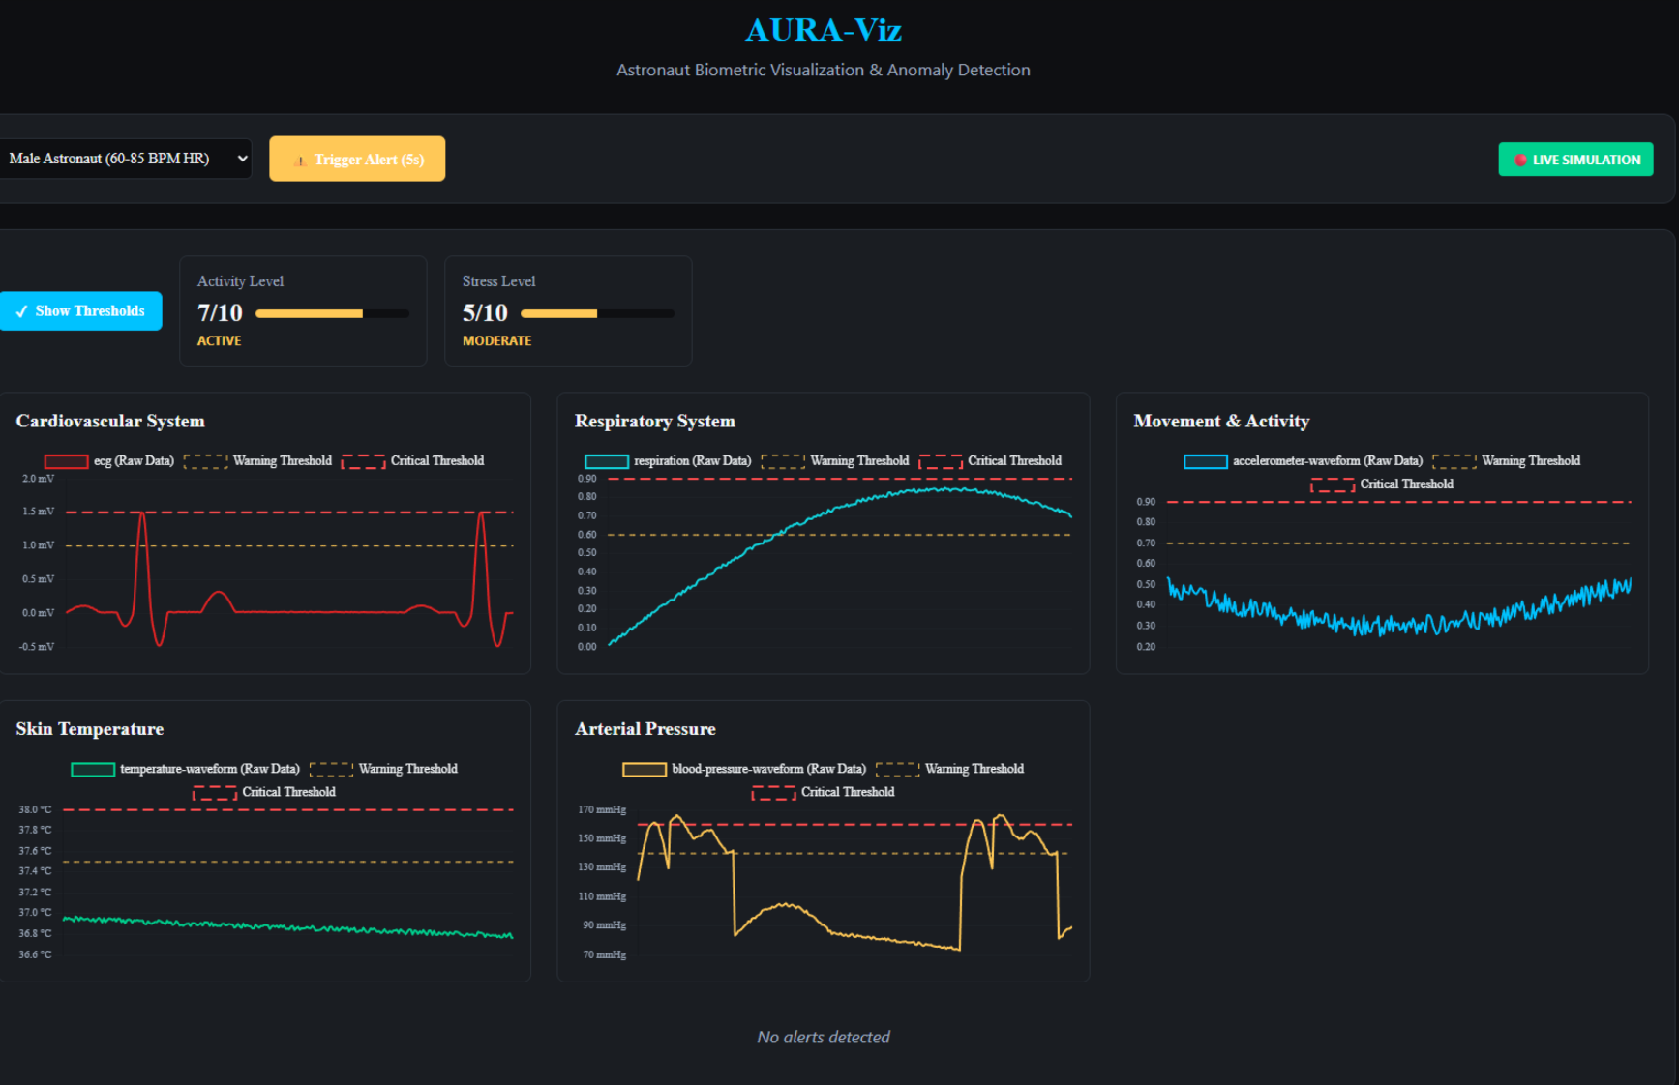

Figure : Backend Dataflow and Simulation [Code in Appendix 1]

Table : Individual Vital Sign Alert Thresholds

|  |  |  |  |  |
| --- | --- | --- | --- | --- |
| Metric | Physiological State | Normal Range | Warning (Yellow) Alert | Critical (Red) Alert |
| **Heart Rate (HR)** | (All States) | ≤ 100 bpm | > 100 bpm | > 120 bpm |
| **Respiration (RR)** | **Resting** | 10–25 breaths/min | < 10 or > 25 | < 8 or > 30 |
|  | **Light Activity** | ≥ 12 breaths/min | - | < 12 |
|  | **Sustained Exercise** | ≥ 20 breaths/min | - | < 20 |
| **SpO2** | (All States) | ≥ 95% | 92% to < 95% | < 92% |
| **Temperature** | (All States) | ≤ 37.5°C | > 37.5°C | > 39°C |
| **HRV (RMSSD)** | (All States) | ≥ 20 ms | < 20 ms | - |

Table : Data Fusion Alert Criteria

|  |  |  |  |  |
| --- | --- | --- | --- | --- |
| Alert Name | Severity | Trigger Conditions | Required Sensors | Rationale |
| **Hypoxia** | **CRITICAL** | SpO2 < 92% | Oximeter | Indicates severe lack of oxygen, a life-threatening medical emergency. |
| **Respiratory Distress** | **CRITICAL** | RR > 35 AND SpO2 < 94% AND Activity < 40 | Respiration, Oximeter, Accelerometer | Detects inefficient breathing (high effort with poor oxygenation) while at rest or during light activity. |
| **Potential Infection** | **CRITICAL** | HR > 90 AND Temp > 37.5°C | Heart Rate, Temperature | A coordinated rise in heart rate and temperature is a classic and highly reliable early signature of the body mounting an immune response. |

### 2.5.6 AURA Ecosystem Response

The AURA ecosystem transforms raw biometric data into actionable medical and operational support through a multi-tiered, intelligent response protocol. This closed-loop system is designed to function effectively across the communication latency of deep space, ensuring astronaut health is managed proactively and autonomously.

The response hierarchy is as follows:

1. **Autonomous AI Intervention:** The AURA AI continuously analyses the incoming data stream for specific patterns. For common, non-critical anomalies that can be resolved without human intervention, the system acts automatically. For example:
   * If it detects biometric markers of rapidly increasing stress (e.g., spiking heart rate, high heart rate variability), it can autonomously simplify the AR display, reduce notification volume, or provide calming audio prompts to de-escalate the situation.
   * If it infers signs of spatial disorientation or cognitive overload, it can simplify interface elements to reduce cognitive load.
   * This level of response provides immediate mitigation for well-understood issues, preventing them from escalating and reducing the burden on the crew.
2. **Onboard Crew Notification and Action:** The system empowers the astronauts and the Crew Medical Officer (CMO) with information and tools.
   * **Awareness:** Relevant health information is displayed to the astronaut themselves, promoting self-awareness and allowing them to self-regulate (e.g., taking a break if fatigue levels are high).
   * **CMO Alert & AI-Assisted Diagnosis:** For more complex anomalies, the AURA system immediately alerts the onboard CMO. It provides not just the raw data, but also its analysis, potential diagnoses, and AI-guided procedural support using enhanced checklists and protocols.
   * This enables the CMO to make independent diagnoses and perform treatments without initial ground input.
3. **Ground Support and Asynchronous Care:** Despite the autonomy, Earth-based expertise remains a critical part of the loop.
   * **Routine Data Transmission:** Data is periodically sent to the ground station for routine check-ups by flight surgeons.
   * **Anomaly Transmission & Plan Development:** When an abnormal event occurs, all relevant data is transmitted to Earth. The ground team, including flight surgeons and the medical team, can then monitor the condition asynchronously and develop a comprehensive treatment plan.
   * **Plan Execution:** This treatment plan is uploaded back to the space station. The CMO and the affected astronaut can then carry out the plan with the continued support and guidance of the AURA system.
4. **Predictive Warning and Risk Mitigation:** A key advantage of continuous monitoring is the shift from reactive to predictive healthcare. The AI can identify subtle trends and patterns that indicate an increased risk for a future medical event. This allows the system to issue predictive warnings to both the astronaut and the ground station *before* a situation becomes critical, enabling early preventive measures.
5. **Contingency Protocol:** In a severe emergency where onboard care is insufficient, the ultimate protocol remains the evacuation and return of the astronaut to Earth. The Biometric Monitoring System ensures this decision is based on comprehensive, real-time data rather than relying solely on self-reporting, allowing for faster and more informed critical decision-making.

In summary, the ecosystem ensures that the right level of response is triggered at the right time. From fully autonomous AI acts to AI-assisted crew procedures and ground-supported care, it creates a resilient, multi-layered defence for astronaut health.

### 2.5.7 Future Development

The current AURA Biometric Monitoring System provides an unparalleled, real-time view of an astronaut's physiological state. However, to truly secure the future of long-duration deep space missions, healthcare must evolve from being reactive and real-time to becoming predictive and deeply personalized. The next revolutionary leap lies in the integration of advanced genomic artificial intelligence, specifically a system like Google DeepMind's AlphaGenome, into the AURA framework [27] [28].

AlphaGenome represents a transformative AI model designed to decipher the regulatory "dark matter" of the human genome, the 98% of non-coding DNA that orchestrates gene activity [29]. Unlike previous models focused on protein-coding regions, AlphaGenome can process up to one million DNA base pairs at single-letter resolution, predicting how small genetic variations (mutations) impact thousands of molecular properties, from gene expression and RNA splicing to chromatin accessibility [27]. This capability allows researchers to understand the functional impact of variants linked to disease with unprecedented accuracy.

#### 2.5.7.2 The AlphaGenome Integration

Integrating AlphaGenome would create a powerful synthesis of an astronaut's static genetic blueprint and their dynamic physiological data.

1. **Pre-Flight Genetic Mapping & Risk Assessment:** Pre-mission, each astronaut's genome would be sequenced. AlphaGenome would analyse this data to identify innate predispositions, such as:
   * Variations in DNA repair gene efficiency that could increase radiosensitivity.
   * Predispositions to specific cancers or cardiovascular issues.
   * Pharmacogenomic profiles indicating how an individual might metabolize certain countermeasure drugs [30]
2. **In-Mission Predictive Health Monitoring:** Fused with Astroskin's real-time biometric data, the AI could perform hyper-personalized risk prediction.
   * The system wouldn't just see a rising heart rate; it would see it in an individual with a genetic predisposition for a specific arrhythmia, drastically improving early warning accuracy.
   * It could correlate radiation exposure dosimetry with the expression of radiation-responsive genes, providing a dynamic, biological measure of radiation damage beyond physical dosimeters [31]
3. **Personalized Countermeasures:** This genomic insight would allow for truly personalized countermeasures.
   * **Exercise & Nutrition:** Regimens could be tailored based on a genetic profile that shows a higher propensity for fast-twitch muscle loss or specific vitamin absorption issues.
   * **Pharmacogenomics:** Medication type and dosage could be pre-selected based on an astronaut's unique genetic ability to metabolize them, maximizing efficacy and minimizing side effects in a resource-limited environment [30]

Table : Potential Development with AlphaGenome Compared to Current Capabilities

|  |  |  |
| --- | --- | --- |
| Component | Current AURA Capability | Future State with AlphaGenome Integration |
| Risk Assessment | Real-time, based on physiology. | Predictive. Based on genetic predisposition + real-time physiology + radiation exposure. |
| Radiation Monitoring | Physical dosimetry (measurement of dose). | Biological dosimetry. Measurement of biological *response* to dose via genetic markers |
| Medical Interventions | Standardized protocols and medications. | Hyper-Personalized. Drugs and doses selected based on individual pharmacogenomic profile. |
| Scope of Care | Somatic (individual astronaut's body). | Longitudinal & Heritable. Understanding of individual risks and potential impacts on long-term health. |

#### 2.5.7.3 Challenges and Ethical Considerations

This future is not without significant hurdles, which is why it remains a development pathway rather than an immediate implementation [27].

* **Technological & Computational Constraints:** The computational power required for whole-genome analysis and running complex models like AlphaGenome is currently prohibitive for a spacecraft's limited resources. Its accuracy diminishes for genetic interactions over 100,000 base pairs away.
* **Data Interpretation Gaps:** While AlphaGenome predicts molecular outcomes, it does not give the full picture of how genetic variations lead to complex traits or diseases, which involve broader biological processes, developmental stages, and environmental factors.
* **Ethical and Privacy Frameworks:** The use of genetic data necessitates extremely robust ethical guidelines concerning privacy, consent, and the potential misuse of predictive health information within a small, isolated crew. AlphaGenome is explicitly "a research tool" and "hasn't been designed or validated for personal genome prediction". [32]

## 2.6 The AURA Adaptive Contingency Engineering (ACE) Module

To elevate AURA from a system of proactive guidance to one of creative, collaborative problem-solving, an ambitious additional layer is proposed: the AURA Adaptive Contingency Engineering (ACE) Module. This module, formerly known as the Generative Problem-Solving (GPS) Module, has been renamed to better reflect its function, generating novel engineering solutions for unplanned contingencies, and to avoid confusion with the Global Positioning System. The ACE module integrates a Generative Engineering Model (GEM) directly into the AURA AI Brain, activating in high-stakes scenarios where no pre-existing solution or spare part exists.

This capability is grounded in the real-world advancements of generative AI for 3D asset creation, such as Zoo Cad. The workflow for the ACE module is as follows: **Problem Definition & Data Capture:** The process begins with the astronaut capturing the physical parameters of an unprecedented problem, such as a fractured structural latch, using integrated tools like a handheld structured-light or LiDAR 3D scanner. This provides the GEM with a high-fidelity point cloud or mesh of the as-is condition.

1. **Image-to-3D Reconstruction:** The system employs a sophisticated image-to-3D pipeline to process the raw scan data and accompanying imagery. This converts the potentially noisy scan into a clean, topologically sound, and workable 3D model that serves as the foundation for the new design.
2. **Constraint Specification via NLP:** The astronaut provides high-level constraints via voice command: *"AURA, design a functional replacement latch. The new part must be 3D-printable from the onboard* ***PEEK*** *thermoplastic stock, interface with these scanned mounting points, and be installable using only the tools in the standard EVA repair kit."* The local LLM accurately parses these multi-domain constraints (material properties, manufacturing method, physical interfaces, tooling).
3. **Generative Design & Material Science Integration:** This is the core of the ACE module. The GEM processes these inputs, fully aware of the unique physics and material science constraints of on-orbit fabrication.
   * **Environment-Informed Design:** The model designs a part engineered to survive the harsh realities of space. Its optimisation algorithms account for the synergistic threats of **ionizing radiation, extreme thermal cycling (-175°C to 160°C), and atomic oxygen erosion** (See Appendix XXX, Table 6 for details).
   * **Process-Specific optimisation:** The GEM's simulations are tailored to the onboard **Fused Filament Fabrication (FFF)** printer—the proven workhorse for in-space AM. It accounts for the challenges of microgravity, such as the absence of thermal convection (requiring careful heat management to prevent warping) and the reliance on surface tension and controlled extrusion for layer adhesion.
   * **Materials-Driven Performance:** The choice of PEEK (Polyetheretherketone) is deliberate. The GEM accesses a detailed material profile, selecting it for its exceptional thermal stability (service temp. ~260°C), inherent radiation resistance, and, critically, its near-zero outgassing (CVCM: 0.00%), which prevents the contamination of sensitive optical and electronic systems.

Table : Comparative Properties of Space-Grade AM Polymers

|  |  |  |  |  |
| --- | --- | --- | --- | --- |
| **Property** | **PEEK** | **PEKK** | **PEI (ULTEM 9085)** | **Unit** |
| Continuous Service Temp. | ~260 | ~260 | ~175 | °C |
| Tensile Strength | ~100 | ~90-100 | ~47 | MPa |
| Radiation Resistance | Excellent | Very Good | Good | Qualitative |
| Total Mass Loss (TML) | 0.14 - 0.31 | 0.41 | 0.40 - 0.48 | % |
| CVCM | **0.00** | **0.00** | **0.00** | % |

1. **Solution Validation & Manufacturing:** The generated solution is presented to the astronaut as an interactive 3D model in the AR display for inspection and approval. The astronaut can virtually manipulate the part and overlay it on the damaged area to confirm fit. Once validated, the final, print-ready design file is sent to the onboard FFF printer for autonomous manufacturing.
2. **Procedure Generation:** Concurrently, the AI analyses the geometry of the newly designed part and the existing hardware to generate a novel, step-by-step installation procedure, complete with visual overlays and haptic cues.

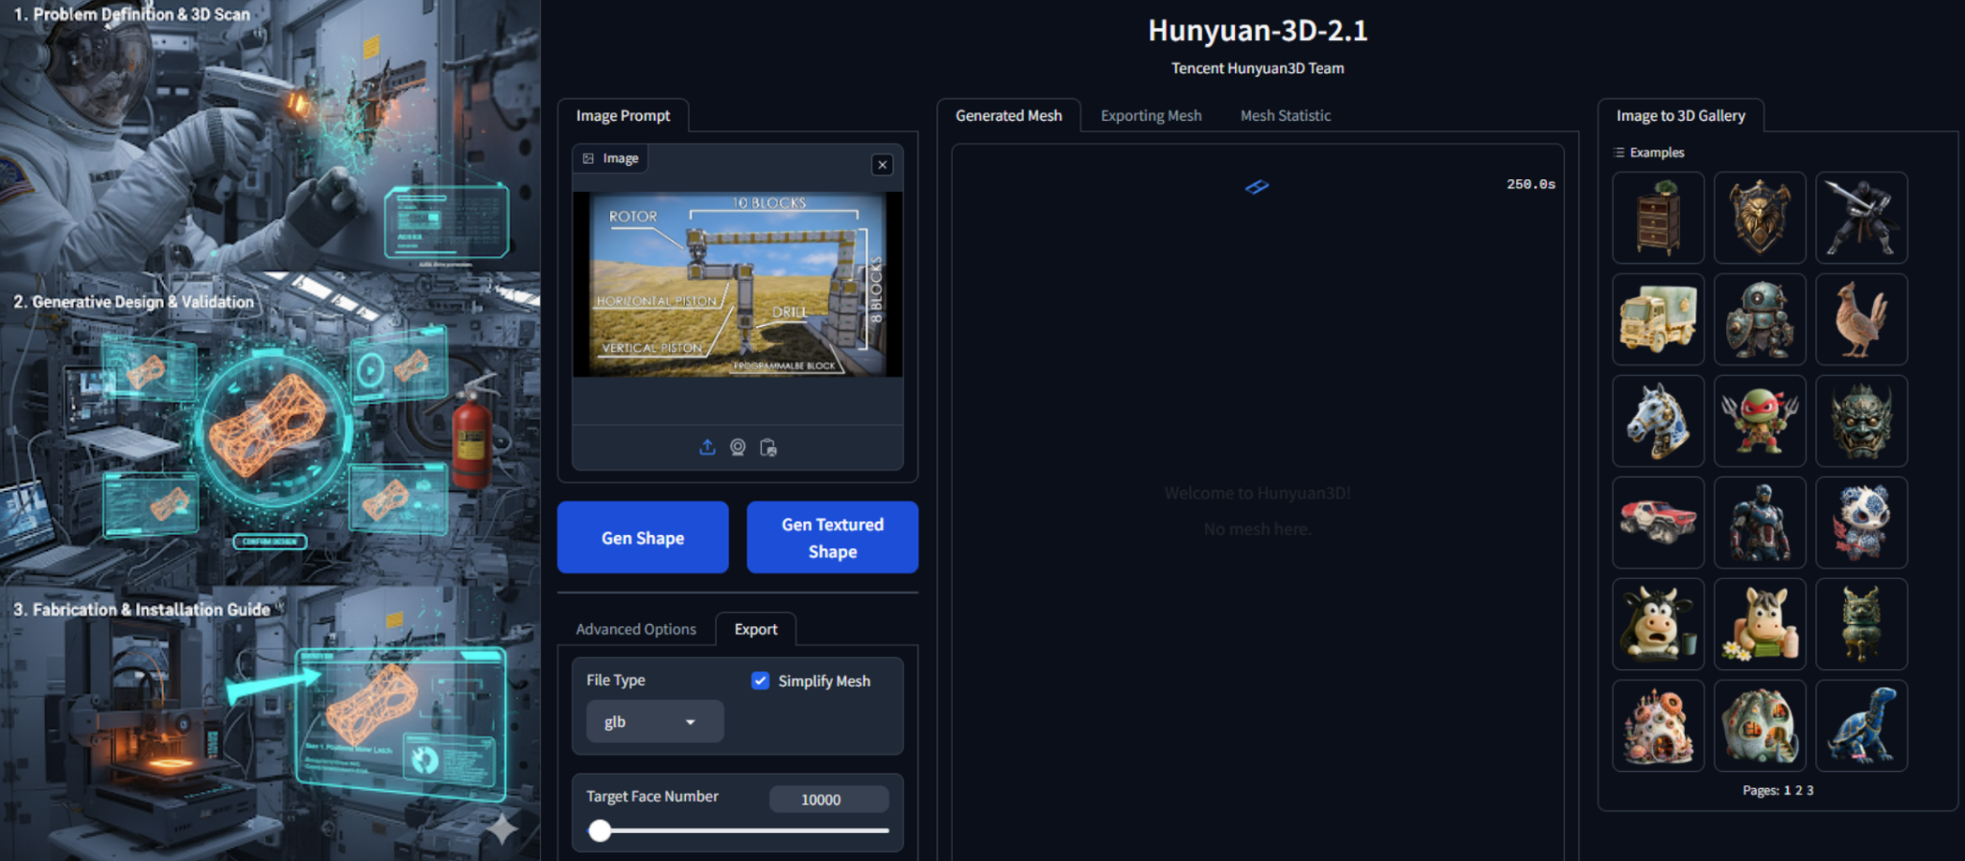

Figure : ACE Module Concept [AI-Image]

### 2.6.1 In-Situ Resource Utilization (ISRU)

While the initial capability of the ACE module centres on using stockpiled, Earth-brought materials like PEEK thermoplastic, its true long-term potential is unlocked by integrating **In-Situ Resource Utilization (ISRU)**. This is the principle of harvesting, processing, and using local materials found on the Moon, Mars, or other celestial bodies to create a self-sustaining and independent human presence in space [A]. By enabling the ACE module to use mined resources, it is transformed from an emergency repair system into a foundational tool for construction, manufacturing, and settlement.

The primary feedstock for lunar ISRU is **regolith**, the layer of dust, broken rock, and fine soil that covers the Moon's surface. This seemingly simple material is a rich source of valuable elements, with oxygen, silicon, iron, and aluminium being the most abundant [B]. The key technological enabler for processing these resources is a method like **Molten Regolith Electrolysis (MRE)**, a process being perfected by systems such as Blue Origin’s Blue Alchemist [C]. MRE involves heating regolith to approximately 1,600°C and using an electrical current to separate the constituent elements, primarily oxygen, silicon, iron, and aluminium, without requiring water or other chemical reagents brought from Earth [C].

The AURA ACE workflow is perfectly suited to this evolution. The core process of scanning a problem, specifying constraints, and generating a design remains unchanged. The critical adaptation occurs at the constraint and material science level. An astronaut would issue a command such as:

*"AURA, design a replacement structural support. It must interface with these scanned points and be manufacturable from sintered lunar iron alloy."*

The Generative Engineering Model (GEM) would then access a different material profile, optimising the component's topology for the properties of a metallic alloy produced in-situ, and dispatch the final design to a manufacturing system capable of processing the mined materials, such as a Selective Laser Sintering (SLS) 3D printer or a casting mould [A]. This capability fundamentally alters the logistics of deep space missions, enabling the on-demand creation of everything from simple tools and repair parts to complex components for habitats, solar arrays, and infrastructure.

Please refer to Appendix XXX for the details on the properties and applications of primary materials derivable from lunar regolith.

[A] National Aeronautics and Space Administration (NASA). (2023). *Additive Manufacturing for the Final Frontier: Materials, Processes, and Applications of Space-Grade 3D Printing*. NASA Technical Reports Server.

[B] Blue Origin. (2024). *Blue Alchemist: Comprehensive Materials Properties Research*. Blue Origin Media.

[C] Blue Origin. (2025). *Blue Alchemist: Executive Summary*. Blue Origin Media.

[D] Seah, D., Goh, R., Chua, T. I., & Wong, J. S. T. (2023). *Mining Infrastructure and New Innovations on New Space (MARK-1)*. International Space Challenge 2024 Open Submission. Unpublished

## 2.7 The VPK Subsystem: An Embodied Kinematic Model

The pinnacle of the AURA architecture is the Visual Proprioceptive Kinematics (VPK) subsystem, a groundbreaking component that transforms the system from environmental awareness to true embodied intelligence. While the AI Brain provides cognitive capabilities and environmental understanding, the VPK subsystem grants the AI something fundamentally different: proprioception, a learned, dynamic understanding of the astronaut's physical body, its movements, and its interaction with the surrounding environment.

The VPK subsystem addresses a critical limitation in current human-machine interfaces: the inability of AI systems to understand the physical embodiment of their human partners. Traditional approaches treat the human operator as an abstract decision-maker moving through a static world. The VPK subsystem recognizes that effective human-AI symbiosis requires the AI to comprehend not just what the human intends to do, but what they are physically capable of doing, how they are currently moving, and how their body interacts with the constraints of the spacesuit and environment.

Neural Jacobian Field Architecture: The technical foundation of the VPK subsystem is built upon cutting-edge Neural Jacobian Field (NJF) methodology, a revolutionary approach to vision-based kinematic modelling that has been successfully demonstrated on diverse robotic systems. The NJF architecture employs two synergistic neural networks: a Neural Radiance Field (NeRF) that reconstructs the 3D geometry of the astronaut-in-suit, and a novel Visuomotor Jacobian Field that maps every point in 3D space to its corresponding motion sensitivity under different actuator commands.

In the context of AURA, the "actuator commands" are the astronaut's own voluntary movements. The Jacobian field learns to predict how every visible part of the suited astronaut will move in response to the human's intentions, effectively creating a real-time, adaptive kinematic model without requiring any pre-existing CAD models or embedded sensors in the suit itself.

Self-Supervised Learning Pipeline: The VPK subsystem is trained through a sophisticated yet elegant self-supervised learning process. During pre-mission preparation or early mission phases, the astronaut performs routine movements and tasks while being observed by a strategically positioned array of 12-15 consumer-grade RGB-D cameras integrated into the habitat or EVA workspace. No human annotation or expert modelling is required, the system learns purely through observation.

The training captures the natural relationship between the astronaut's voluntary movements and the resulting kinematics of the suit-human system. This includes the complex, non-linear dynamics introduced by suit pressurization, material constraints, joint limitations, and the astronaut's individual biomechanics. The learned model automatically accounts for factors that would be impossible to model analytically: how fatigue affects movement patterns, how suit wear influences joint mobility, or how tool usage changes the effective kinematics of the system.

Real-Time Kinematic Inference: Once trained, the VPK subsystem operates from a single camera view, continuously inferring the complete 3D kinematic state of the astronaut from visual observation alone. The system constructs a high-fidelity "digital twin" that tracks the precise position, orientation, and movement of the astronaut's head, torso, arms, and legs in real-time. This digital twin is not a static model but a dynamic representation that adapts to the astronaut's current state, capturing changes in mobility, fatigue, or suit configuration.

The core mathematical relationship governing the VPK system is expressed as:

δx = J(x, I)δu

Where δx represents the predicted 3D motion of any point x on the astronaut's body, J(x, I) is the learned Jacobian field queried at that point given the current image I, and δu represents the inferred movement command or intention.

Integration with AURA Ecosystem: The VPK subsystem serves as a foundational enabler for all other AURA components, providing each with unprecedented insight into the astronaut's physical reality:

AR/XR Interface Enhancement: The VPK model enables body-centric guidance, where visual overlays are rendered relative to the astronaut's own limbs rather than just the external environment. This allows for hyper-accurate procedural guidance, dynamic collision avoidance warnings for the suit itself, and real-time ergonomic feedback to optimize energy expenditure.

ACE Module Validation: The VPK digital twin enables the critical ergonomic simulation step in the ACE workflow, allowing the system to verify that any newly designed component is not just structurally sound but physically installable by the specific astronaut, accounting for their reach limitations, joint mobility, and line-of-sight constraints.

Biometric Integration: By fusing VPK kinematic data with biometric physiological data, the AI can differentiate between physical, cognitive, and psychological stressors with unprecedented accuracy, enabling personalized metabolic modelling and predictive fatigue management.

Adaptive Learning and Mission-Long Calibration: Unlike static kinematic models, the VPK subsystem can be continuously or periodically recalibrated throughout a mission. EVA footage from each day's operations can be processed overnight to fine-tune the model, ensuring the AI's understanding of the astronaut's capabilities remains current as physical condition, suit wear, or environmental factors change over time. This adaptive capability is critical for long-duration missions where static models would quickly become obsolete.

Technology Readiness and Development Path: The core NJF methodology underlying the VPK subsystem has been validated at TRL 3-4 through successful demonstrations on diverse robotic platforms. The path to space qualification involves adapting the training pipeline for human subjects and spacesuit-specific applications (TRL 5), demonstrating prototype functionality in relevant environments such as underwater neutral buoyancy facilities (TRL 6), and integration with prototype AURA systems for comprehensive testing in analogy missions (TRL 7-8) before final flight qualification.

The VPK subsystem represents the technological bridge between AURA's cognitive capabilities and the physical reality of human space exploration. By granting the AI a true understanding of the astronaut's embodied presence, the VPK subsystem enables a level of human-machine partnership that transcends traditional interfaces, creating a symbiotic relationship where the AI becomes not just an information provider, but a physical partner that understands and anticipates the human's needs, capabilities, and limitations in the unforgiving environment of space.

### 2.7.1 Operational Impact and Future Directions

The integration of Neural Jacobian Fields for Volumetric Position Kinematics represents a compelling but complex future direction for astronaut movement modelling in space environments. While the theoretical potential for creating real-time adaptive models of astronaut kinematics is significant, this technology requires careful consideration as a long-term strategic goal rather than an immediate implementation.

The technical vision of multi-modal sensor fusion with machine learning presents substantial ethical and operational hurdles that must be resolved before any deployment can be considered. Primary among these are concerns regarding privacy boundaries with continuous biometric monitoring, potential erosion of crew trust through perceived surveillance, and unresolved legal frameworks for predictive health data usage in isolated space environments. The current technological maturity also presents challenges for reliable operation in safety-critical space operations.

As such, this enhancement is positioned as a future development stretch goal, contingent upon parallel progress in several key areas: establishing robust ethical guidelines for human-AI interaction in confined spaces, developing enforceable data governance policies, and achieving sufficient technological reliability for autonomous operation during communication-blackout periods. The foundational research outlined here provides a valuable framework for continued Earth-based investigation, with any space-based deployment awaiting comprehensive resolution of these critical human factors and safety considerations.

While the terrestrial applications in rehabilitation and industrial safety may proceed more rapidly, the space-based implementation will require measured, principled development to ensure that technological advancement never compromises the human trust and operational safety essential for successful deep-space exploration.

# 3.0 Power, Security, Legality, and Human Factors

This chapter provides a detailed examination of the foundational architectures and principles that underpin the AURA system's operational viability. It addresses the critical non-functional requirements that are as essential to mission success as the system's primary capabilities. The analysis moves from the physical layer of power generation to the digital layer of cybersecurity, the procedural layer of human-computer interaction, and the abstract layer of legal compliance, culminating in a holistic assessment of the system's technological readiness. Each domain presents unique challenges that must be solved to enable a truly autonomous human-AI symbiote in the unforgiving environment of deep space.

## 3.1 AURA Power Architecture: A Sovereign Radioisotope Power System

The AURA system represents a new class of device for Extravehicular Activity (EVA), functioning as a wearable, symbiotic supercomputer. This unprecedented capability brings with it a significant power demand, far exceeding that of any current suit-integrated electronics. The system's power profile is highly dynamic, varying based on the operational context, from a near-idle standby state to computationally intensive peak performance during critical events.

This section provides a comprehensive engineering analysis of the AURA system's power requirements and proposes a hybrid power architecture designed to meet these demands while adhering to the stringent safety, mass, and longevity constraints of long-duration deep space missions.

### 3.1.1 Power Demand Analysis for a Human-AI Symbiote

A quantitative power demand analysis is a prerequisite for the design and validation of a viable power architecture for the AURA system. The following analysis establishes a component-level power budget founded on the technical specifications of the selected flight-candidate hardware. The total system power budget is a summation of its constituent subsystems, with each characterized across three primary operational modes: Quiescent Standby, Nominal Operation, and Peak AI Inference.

The AI Compute Module represents the largest and most dynamic electrical load. To ensure maximum reliability in the harsh deep space environment, the module is designed around a purpose-built, radiation-hardened System-on-Chip. The leading candidate is the **AMD XQR Versal AI Core**, an Adaptive Compute Acceleration Platform (ACAP). Its selection is predicated on its radiation-tolerant design, qualification to 100 krad(Si) Total Ionizing Dose (TID), immunity to Single-Event Latch-up (SEL), and heterogeneous compute architecture, which is highly efficient for complex AI workloads (Advanced Micro Devices [AMD], n.d.). Based on manufacturer specifications, its power envelope is characterized by three distinct states: a Quiescent Standby mode drawing approximately 9 W, a Nominal Operation mode at 42 W, and a Peak AI Inference mode reaching 112 W.

The power demands of the other AURA Peripheral Subsystems are comparatively low. The AR/XR Display, Haptic Feedback Patch, and the flight-proven Astroskin (Bio-Monitor) system have stable power draws well under the AI module's requirements. This component-level analysis allows for the construction of a detailed system-wide power budget, as synthesised in Table 7.

Table : AURA System Power Budget Across Operational Modes

|  |  |  |  |
| --- | --- | --- | --- |
| Component | Standby Power (W) | Nominal Operation Power (W) | Peak AI Inference Power (W) |
| **AI Compute Module (Versal)** | 9 | 42 | 112 |
| **AR/XR Display** | 2 | 5 | 8 |
| **Haptic Patch** | 0.5 | 2 | 5 |
| **Biometric System** | 0.5 | 1 | 1 |
| **TOTAL** | **12** | **50** | **126** |

### 

### 3.1.2 A Critical Review of Power Sources for Deep Space EVA

To address the unique power demands of the AURA system, it is necessary to logically narrow the field of potential technologies. Conventional power sources are demonstrably inadequate for this specific application.

**Chemical Batteries**, such as lithium-ion cells, lack the specific energy (Wh/kg) to sustain a multi-hundred-watt load for the 6- to 8-hour duration of a standard EVA without incurring a prohibitive mass penalty. Advanced space-qualified rechargeable lithium-ion cells typically reach up to 180 Wh/kg (e.g. the VL 37570 at ~180 Wh/kg), considerably below the 0.55 kWh EVA requirement without prohibitive mass penalty. Saft’s higher-energy offerings are exclusively in its non-rechargeable Li-SOCl₂ (LS/LSH) primary range, up to 700 Wh/kg, but these cannot be cycled. (XXX [SAFT, n.d.](https://saftlithium.nl/datasheets/BIN_2013Lithium-catalogue-UK_2013.pdf)).

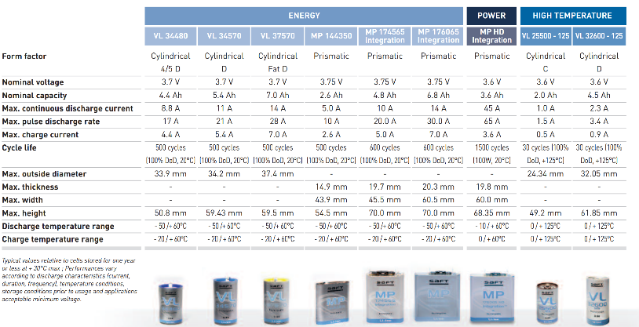

Figure : Lithium-ion (Li-ion) batteries from Saft

**Solar Power** arrays are the workhorse of most spacecraft but are fundamentally unsuited for this application. Their reliance on direct sunlight makes them useless in the permanently shadowed craters of the Moon's poles, a key target for the Artemis program, or during the two-week lunar night (XXX S[olestial, n.d.](https://solestial.com/)).

This systematic elimination leaves Radioisotope Power Systems (RPS) as the only viable class of technology capable of providing the continuous, long-term, and solar-independent power required.

### 3.1.3 Candidate RPS Technologies for Suit-Integrated Systems

Within the class of RPS, three primary technologies warrant consideration. A rigorous comparative analysis against the specific constraints of a wearable, suit-integrated system is required to select the optimal approach.

Table : Comparative Analysis of RPS Technologies for a Wearable AURA System

|  |  |  |  |  |
| --- | --- | --- | --- | --- |
| Technology | Typical Power | Key Advantage | Critical Disadvantage for Wearable Use | Suitability for AURA |
| **RTG (MMRTG) [**[**XXX**](https://www.nasa.gov/wp-content/uploads/2015/08/4_mars_2020_mmrtg.pdf)**]** | ~110 W | TRL 9, No moving parts | Prohibitive heat output (~1.9 kW), mass, and shielding | Unsuitable |
| **SRG (ASRG) [**[**XXX**](https://ntrs.nasa.gov/api/citations/20160005946/downloads/20160005946.pdf)**]** | ~140 W | High efficiency (~4x RTG) | Moving parts introduce reliability/vibration concerns; lower TRL | High Risk / Unsuitable |
| **Betavoltaic** ([NASA, n.d.-a](https://www.nasa.gov/wp-content/uploads/2024/01/04-nasa-workshop-adams.pdf)) | µW - mW | Inherently safe, minimal shielding, extreme longevity, high TRL | Power output is 6-9 orders of magnitude too low for peak demand | Suitable as Primary Source (Requires Hybridization) |

Betavoltaic Devices represent a non-thermal approach to radioisotope power conversion. They function analogously to photovoltaic cells but convert beta particles from a radioisotope source like Tritium (³H) into electricity. This approach offers inherent safety, as the low-energy beta particles require minimal shielding, and extreme longevity, with a predictable power output for 20 years or more, Tritium decay half-life of 12.3 years yields an average beta energy of 5.7 keV and maximum of 18.6 keV, requiring minimal shielding (XXX [City Labs, n.d.-b](https://citylabs.net/products/)). The technology has been matured through NASA-funded initiatives and is commercially available from companies like City Labs, establishing a credible TRL ([NASA, n.d.-a](https://www.nasa.gov/wp-content/uploads/2024/01/04-nasa-workshop-adams.pdf)). The critical limitation, however, is its low power density, necessitating an innovative architectural solution.

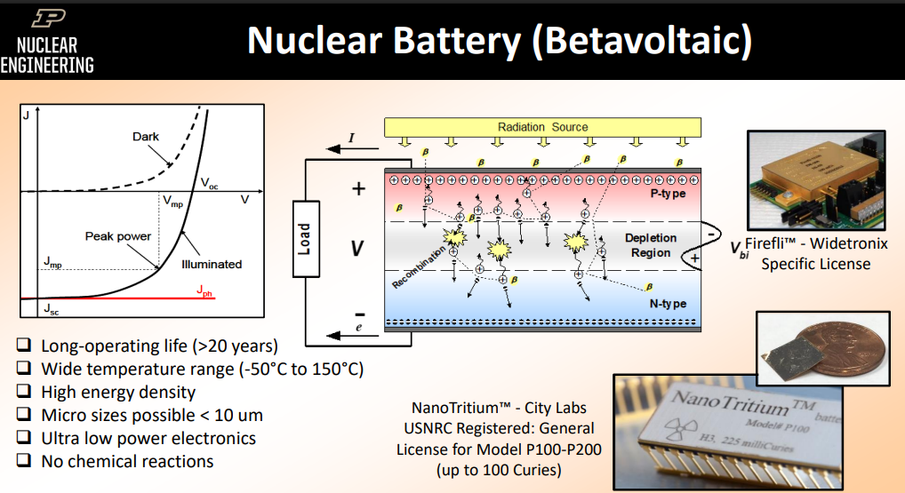

Figure : Nuclear Battery (Betavoltaic) ([NASA, n.d.-a](https://www.nasa.gov/wp-content/uploads/2024/01/04-nasa-workshop-adams.pdf))

### 3.1.4 Proposed Solution: A Hybrid Betavoltaic Power Architecture

The optimal solution to this "Power Mismatch Paradox" is a novel hybrid power architecture. This system leverages the unique strengths of two distinct, mature technologies, betavoltaics and chemical batteries, to achieve a capability that neither could provide alone. The architecture consists of a Betavoltaic Primary Power Unit (PPU) for continuous energy generation and a Secondary Energy Storage Unit (ESU) for delivering high-power transient loads.

The Betavoltaic PPU will be an array of high-TRL, commercial-off-the-shelf (COTS) tritium-based betavoltaic cells (e.g., City Labs P100 series). The PPU's sole function is to provide a continuous, low-power trickle charge to the ESU, acting as a virtually inexhaustible energy source.

City Labs P100 Series Betavoltaic Specifications: Output = 60-350 nanoamps short-circuit current, 0.8-2.4V open-circuit voltage, 20+ year operational lifetime with predictable decay, Commercial availability and space-qualified temperature range -40°C to +80°C ([City Labs, 2017](https://f.hubspotusercontent30.net/hubfs/20928986/NanoTritium%20Battery%20Spec%20Sheet%20P100a%20%205-4-21.pdf))

The Secondary ESU will be a bank of space-qualified, high-discharge-rate, solid-state lithium batteries. Its role is to accumulate energy from the PPU and deliver the hundreds of watts required for peak AI inference. Based on the power budget and an 8-hour EVA profile, the total energy requirement is calculated as 0.55 kWh. The use of solid-state battery technology enhances safety and performance, with future upgrade paths leveraging NASA's ongoing research in this area, such as the SABERS program ([NASA, n.d.-b](https://www.nasa.gov/aeronautics/nasas-solid-state-battery-research-exceeds-initial-goals-draws-interest/)). This hybrid approach effectively combines the phenomenal energy density of a radioisotope source with the high-power density of a chemical battery.

### 3.1.5 System Integration, Safety, and TRL Assessment

The hybrid power system will be a single, modular pack integrated within the astronaut's Portable Life Support System (PLSS). The safety case for this architecture is exceptionally strong due to the choice of a betavoltaic PPU, whose low-energy tritium beta radiation is easily and completely contained. While the individual components are mature (Betavoltaic Cells at TRL 6-7; Space-Qualified Battery at TRL 9), the integrated hybrid system is a novel application. Therefore, a composite system TRL of 4 (Component and/or breadboard validation in a laboratory environment) is appropriate at the project's outset, with a clear path to flight qualification (TRL 9) through further development and testing.

## 3.2 Security by Design: The Imperative of a Sovereign, Air-Gapped AI

The decision to architect AURA around a locally hosted, sovereign AI is a foundational security principle. In critical deep space environments where the system is a life-support partner, reliance on any external network for core cognitive functions introduces unacceptable risks of remote manipulation or failure. The AURA architecture therefore establishes a **"Cognitive Airgap,"** a system that is fundamentally isolated from external command during real-time operations ([Fortinet, n.d.](https://www.fortinet.com/resources/cyberglossary/what-is-air-gap)).

### 3.2.1 The Cognitive Air-Gap Architecture

The airgap is a security measure where the AURA system is physically and electronically isolated, with no active connections to external networks for its core sense-decide-act functions. This is the most stringent form of network security, designed on the principle that a system not connected to a network cannot be hacked remotely.

This is implemented by running the entire AI software stack, including the multi-agent system and n8n orchestration framework, locally on the suit-integrated, radiation-hardened AMD XQR Versal AI Core. All data processing, from raw biometric streams to LLM inference and agent decision-making, occurs within this closed loop on the astronaut's local hardware. Some specs of AMD XQR: Radiation-hardened: TID tolerance >100 krad(Si), SEL immunity up to 80 MeV·cm²/mg. AI processing: Enhanced AI Engines (AIE-ML) with 2X INT8 and 16X BFLOAT16 performance. Space qualification: MIL-PRF-38535 Class B qualified for up to 7-year mission duration ([AMD, 2025](https://www.amd.com/en/products/adaptive-socs-and-fpgas/versal/space-grade.html)).

### 3.2.2 Data Sovereignty and Mission Resilience

The air-gapped architecture provides two foremost benefits for deep space operations: data sovereignty and mission resilience.

* **Data Sovereignty:** The local-first processing model guarantees that all sensitive data, including continuous biometric streams and psychological state inferences derived from HRV, is processed and stored exclusively within the secure perimeter of the suit.
* **Resilience and Reliability:** The system's complete independence from external networks guarantees core functionality during communication blackouts. This transforms AURA from a mere support system into a critical tool for mission resilience, fulfilling the primary mandate for deep space autonomy.

### 3.2.3 The Secure Data Uplink Protocol for the Digital Twin

While the cognitive airgap is essential for real-time security, a mechanism for asynchronous communication with Earth is necessary for mission analysis and AI model refinement. The system resolves this through a secure, automated data uplink protocol. An onboard **n8n agent** orchestrates a scheduled workflow, gathering logs into an optimized data packet.

The transport layer is managed by **Syncthing ([Syncthing, n.d.](https://docs.syncthing.net/users/security.html))**, a peer-to-peer synchronization tool chosen for its robust security and resilience. All data transmitted via Syncthing is protected by end-to-end TLS encryption, and its ability to resume interrupted transfers makes it perfectly suited for the high-latency, unstable communication links of deep space. The reverse process for updating the onboard AI model follows an even more stringent security protocol. New AI models developed on the Earth-side digital twin are cryptographically signed with a private key before transmission. Upon receipt, the onboard system uses a public key to verify this signature. Only after a successful signature validation will the system deploy the new model, ensuring the integrity of the AI Brain is maintained throughout the mission (a[icas GmbH, n.d](https://www.aicas.com/secure-ai-system-update/).).

## 3.3 Human-in-Command: HCI Principles for High-Stakes Environments

Technology in extreme environments can be a double-edged sword; if poorly designed, it can become a source of distraction and cognitive load, increasing rather than decreasing risk. The Human-Computer Interaction (HCI) design of AURA is therefore guided by principles tailored for high-stakes, high-stress operations. Drawing from decades of design evolution in safety-critical domains like aviation glass cockpits, the system is architected to be a Reliable, Safe & Trustworthy (RST) partner, augmenting rather than supplanting the astronaut's authority.

### 3.3.1 Fostering Trust Through Explainable AI (XAI)

For an astronaut to rely on an AI partner in a life-or-death situation, they must trust it. This trust is built on reliability and transparency. **Explainable AI (XAI)** encompasses methods that make AI models understandable to human users, ensuring the reasoning behind a conclusion is as clear as the conclusion itself.

The integration of a fine-tuned LLM allows for a new level of explainability in AURA. An astronaut can now engage in a natural language dialogue with the system. If AURA suggests an alternative procedural step, the astronaut can ask, *"AURA, why?"* and receive a response like, *"Telemetry indicates anomalous pressure in valve 7B. The standard procedure risks a fluid leak. The alternate procedure isolates this valve first."* This fosters trust, prevents automation bias, and ensures the astronaut remains the ultimate, informed authority, the human-in-command.

### 3.3.2 Mitigating Automation Complacency and Bias

**Automation bias,** the tendency to over-rely on automated systems, and a corresponding reduction in vigilance are significant, well-documented risks in highly automated environments (S[kitka et al., 1999](https://linkinghub.elsevier.com/retrieve/pii/S1071581999902525)). If the astronaut perceives the AI as an infallible partner, their critical oversight may diminish. To counter this, AURA's operational doctrine incorporates a multi-layered mitigation strategy drawn from established practices in aviation:

* **Training:** Astronauts will be required to complete regular, recurring training exercises where they perform complex EVA tasks and emergency procedures **without** AI support to prevent skill atrophy.
* **Accountability:** The "Human-in-Command" protocol is reinforced as an operational doctrine. The astronaut is explicitly and ultimately accountable for all final decisions and actions, regardless of the AI's recommendation.
* **Interface Design:** The AR interface is designed to promote active information seeking and cross-verification rather than passive acceptance.

### 3.3.3 The Biometric-Adaptive Interface as a Cognitive Load Manager

A core HCI innovation within AURA is the **"Auto-Dashboarding"** system, a biometric-adaptive interface designed to proactively manage the astronaut's cognitive load. This feature creates a closed-loop feedback mechanism where the astronaut's own physiological state drives the behaviour of their interface. The Biometric Monitoring System continuously analyses the incoming data stream, calculating key indicators of workload, such as Heart Rate Variability (HRV) to infer stress levels ([Koo, B.-H. (2018)](https://doi.org/10.30773/pi.2017.08.17)). When these metrics cross a predefined threshold, the AI Brain automatically triggers a change in the visual interface by:

* **Simplifying the UI:** Fading out non-essential information like mission timers.
* **Enhancing Focus:** Subtly increasing the prominence of task-critical procedural overlays.
* **Reducing Notifications:** Temporarily suppressing non-critical alerts or communications.

This closed-loop feedback is designed to mitigate cognitive overload and reduce the probability of human error during the most demanding moments of a mission.

## 3.4 Legal framework of data collection in space

The collection of data is a fundamental activity in Project AURA. However, the legal regimes governing this data collection were established in an era of state-centric, technologically simpler missions. Project AURA strains these existing frameworks to their breaking point.

### 3.4.1 The Foundational International Legal Architecture

The cornerstone of space law is the 1967 Outer Space Treaty (OST), which establishes several cardinal principles relevant to data collection. The OST declares space the "province of all mankind," promoting freedom of scientific investigation. Two of its articles are particularly critical [33].

* **Article VI (State Responsibility):** Establishes that states are internationally responsible for national space activities, including those of non-governmental entities. This mandates "authorization and continuing supervision" by a state, making national licensing a prerequisite for any private data collection mission.
* **Article VII (Liability):** Establishes that a "Launching State" is internationally liable for damage caused by its space object.

Subsequent treaties followed which build on to the OST. The Liability Convention (1972) elaborates on absolute liability for damage caused on Earth, and fault-based liability for damage caused in space. The Registration Convention (1975) requires states to register space objects, providing a basic level of transparency. And the UN Remote Sensing Principles (1986) is a non-binding framework encouraging remote sensing for the benefit of all countries and respect for the sovereignty of sensed states. Their voluntary nature is a significant regulatory gap.

### 3.4.2 Application to Data Types

#### 3.4.2.1 Personal and Biometric Data

Systems like Project AURA, which collect continuous physiological data (ECG, HRV) from astronauts, operate in a legal vacuum. Terrestrial data protection laws like the GDPR are territorially based and do not automatically apply in outer space, which is not subject to national appropriation under the OST. This creates an unresolved tension between an astronaut's personal data rights and the lack of a governing legal framework.

#### 3.4.2.2 Operational and AI-Generated Data

The fault-based liability regime of the Liability Convention is ill-suited for autonomous AI. If Project AURA's AI executes a collision-avoidance manoeuvre that inadvertently causes damage, attributing legal "fault" is problematic. The "Human-in-Command" protocol is a necessary defence but can be legally "brittle" if the system is described as a "symbiotic partner" rather than a tool.

Beyond the challenge of liability, the autonomy of AI creates a second legal conflict with the OST's mandate for "continuing supervision" (Article VI). A design like AURA's "Cognitive Airgap," which processes data locally for security, may be unlicensable because it prevents the supervising state from fulfilling this legal duty. Regulators will therefore demand verifiable audit trails and data access.

#### 3.4.2.3 AI-Generated Intellectual Property

The Adaptive Contingency Engineering (ACE) module, which "invents" novel hardware, challenges the foundation of intellectual property law. The global legal consensus, affirmed in the T*haler v Commissioner of Patents* [2021] *FCA 879* (DABUS) case [34], is that an AI cannot be a legal inventor. Consequently, designs generated autonomously by AI are likely unpatentable and fall into the public domain, destroying their commercial value. The system's workflow and documentation must be carefully designed to ensure a human is the legally recognised inventor.

### 3.4.3 Strategic Recommendations & Mitigation

To navigate this complex environment, projects involving advanced data collection in space must adopt a proactive, integrated strategy.

Table : Risk Mitigation Strategy

|  |  |  |
| --- | --- | --- |
| **Risk Category** | **Risk Description** | **Proposed Mitigation Strategy** |
| **Legal (Liability)** | Ambiguous "fault" for AI actions leads to state liability. | 1. Re-frame all languages: Replace "Sovereign AI Brain" and "invents" with "AI Core" and "AI-assisted design." 2. Implement an immutable, comprehensive data logging system for post-incident forensics. |
| **Legal (IP)** | ACE module designs deemed unpatentable. | 1. Re-architect the ACE workflow to require and log significant human creative input and final approval. 2. Legally define the astronaut as the "inventor" in all documentation. |
| **Regulatory (Licensing)** | License denied due to the "airgap" preventing state supervision. | 1. Design a secure "Regulatory Data Port" for audited access by the licensing authority. 2. Engage regulators early to co-develop acceptable AI supervision standards. |
| **Regulatory (Data)** | Lack of a legal framework for astronaut biometric data rights. | 1. Develop a proprietary "Astronaut Data Rights Policy" based on terrestrial best practices (e.g., GDPR principles). |

### 3.4.4 Path Forward: Integrated Readiness

The path forward requires a strategy of integrated readiness. This begins with the proactive and early engagement of national licensing authorities, such as the FAA's Office of Commercial Space Transportation, to build trust and collaboratively define compliance pathways for autonomous systems. Furthermore, AURA should institute a Legal and Ethical Readiness Level (LERL) framework that operates in parallel to the standard Technology Readiness Level (TRL) process; this ensures legal compliance is designed into the system from the outset rather than being added as an afterthought. Finally, AURA could leverage its unique expertise to contribute to policy discussions at international bodies like the UN Committee on the Peaceful Uses of Outer Space (COPUOS), helping to shape practical and innovation-friendly regulations for the future.

### 

### 3.5 System Integration and Readiness Assessment

This concluding section synthesizes the chapter's topics, illustrating how the power, security, HCI, and legal frameworks function as an integrated whole. It provides a final, evidence-based assessment of the system's technological maturity and outlines the path to flight qualification.

### 3.5.1 The AURA Data and Command Pipeline: From Sensor to Symbiotic Action

The effectiveness of the AURA system hinges on its ability to execute its core sense-decide-act loop with minimal latency. The AURA data processing pipeline is therefore designed as a high-throughput, stream-processing architecture, with all critical computation performed locally on the suit-integrated hardware. A typical data flow for a critical event, such as a thermal hazard, proceeds as follows:

1. **Data Acquisition:** A sensor, for example, a temperature probe on the astronaut's fingertip, detects a rapid increase in temperature. Simultaneously, the Bio-Monitor registers a corresponding spike in the astronaut's heart rate.
2. **Data Fusion & AI Inference:** The Central AI Brain receives these two data streams. The Systems Agent and Biometric Agent process their respective data. The Orchestrator Agent correlates the events and classifies the combined pattern as a "High-Risk Thermal Hazard" event.
3. **Decision Engine:** Based on the "High-Risk" classification, the AI's decision engine immediately prioritizes this event, accessing the pre-defined response protocol.
4. **Multimodal Output Generation:** The decision engine dispatches two simultaneous commands: one to the haptic patch controller to initiate an urgent vibration pattern, and one to the AR display controller to render a red, flashing "HOT" icon overlaid on the hazardous surface.
5. **Action and Feedback:** The astronaut feels the vibration and sees the warning, instinctively withdrawing their hand. The biometric system registers a decrease in heart rate as the threat is averted. This new data is fed back into the AI Brain, confirming the successful mitigation of the hazard and closing the loop.

For this entire pipeline to be effective for real-time hazard avoidance, the latency from initial sensor reading (Step 1) to multimodal output (Step 4) must be kept to an absolute minimum, ideally **under 100 milliseconds**, to be faster than human reflex time. This necessitates the highly optimized software and dedicated local processing hardware of the air-gapped architecture.

### 3.5.2 Hardware and Software Stack: A TRL-Based Analysis

The AURA system is a complex integration of cutting-edge hardware and software. The following table provides a component-by-component breakdown, assessing the current Technology Readiness Level (TRL) and outlining the necessary steps to achieve flight readiness (TRL 9).

Table : AURA Component Stack and Technology Readiness Level (TRL) Assessment

|  |  |  |  |
| --- | --- | --- | --- |
| System Component | Proposed Technology | Current TRL | Path to Flight Qualification (TRL 9) |
| **AR/XR Display** | Custom integrated helmet HUD + Even G1 for while in spacecraft | TRL 5 | Integrate optical package into a prototype EVA helmet, test in vacuum and thermal chambers. Full system validation in analogue mission. |
| **AI Compute Module** | AMD XQR Versal AI Core | TRL 6-7 | Integrate into AURA prototype and validate full software stack performance in an operational environment (analogue mission). |
| **Haptic Actuators** | Vibrotactile Motors | TRL 3-4 | Develop and test a prototype haptic layer integrated into an unpressurized and then pressurized glove. |
| **Biometric Shirt** | Astroskin / Bio-Monitor | TRL 9 | Already flight-proven. Primary work is software integration. |
| **Central AI Software** | Locally deployed, fine-tuned SLM | TRL 4-5 | Demonstrate the full AURA AI software stack running on prototype hardware in an operational environment (analogue mission). |
| **Hybrid Power System** | Betavoltaic PPU + Solid-State ESU | TRL 4 | Develop engineering prototype; validate in thermal vacuum chamber; full system demo in analogue mission. |

### 3.6 Risk Assessment and Mitigation

A comprehensive risk assessment is crucial for any complex engineering project. This section outlines the primary risks identified, assesses their potential impact, and details the multi-layered mitigation strategies designed to ensure system resilience, crew safety, and mission success.

The most significant risks stem from the core Artificial Intelligence. To mitigate the danger of AI hallucination or inaccuracy, which could provide catastrophic incorrect guidance, we will implement a rigorous validation framework using curated, domain-specific datasets. Furthermore, to counter automation complacency, where astronauts might over-rely on the AI, we will mandate regular training exercises without AI support and design the interface to promote situational awareness, forcing cross-verification of key data.

From a hardware perspective, radiation-induced computational failures present a severe threat. This will be mitigated at the source by using radiation-hardened components. Data integrity and ethical handling are also critical. The risk of biometric data misinterpretation will be controlled through multi-sensor fusion, requiring correlation across several physiological streams before triggering alerts, and by incorporating astronaut self-reporting to provide context.

Legal and operational risks are addressed through proactive engagement. The legal ambiguity surrounding AI liability and intellectual property will be mitigated by early collaboration with regulatory bodies to define compliance pathways. We will also design the ACE module's workflow to ensure a human is the legally recognized inventor of any AI-assisted designs.

It is important to note that two features, the AlphaGenome genomic integration and the VPK-NJF kinematic model, are designated for future development cycles only. This decision is based on their current lower Technology Readiness Level, significant ethical and computational hurdles, and the need for extensive validation in analog environments. Their exclusion from the initial operational baseline allows the core AURA system to mature while these advanced capabilities undergo further, dedicated research and risk reduction.

We utilise a matrix that identifies key risks for Project AURA and outlines the corresponding mitigation strategies. The detailed table can be found in Appendix 3.

## 4.0 Project Management and Viability

A Beyond its technical innovation, the long-term success of Project AURA hinges on a pragmatic and strategic approach to its management, risk mitigation, and commercial potential. This chapter outlines the project's roadmap, from development milestones and budget to a comprehensive dual-use commercialization strategy that leverages AURA's transformative capabilities for both the nascent space economy and high-value terrestrial industries.

### 4.1 Project Timeline and Milestones

Figure : Gantt Chart (Detailed Breakdown in Appendix 5)

The development of AURA is structured as a multi-phase project, progressing through NASA's Technology Readiness Levels (TRL). The timeline is designed to be ambitious yet achievable, focusing on iterative development, testing, and validation.

### 4.2 Expected Budget

The project's financial requirements are broken down into two key stages: an initial 6-month proof-of-concept phase to demonstrate core feasibility, and a comprehensive 5-year budget to achieve full flight qualification and operational readiness.

The initial budget prioritises the use of Commercial-Off-The-Shelf (COTS) hardware and open-source software to validate the AURA concept efficiently. Personnel costs are estimated based on typical graduate research stipends to quantify the required human effort. The following table provides a top-level summary of the estimated costs over the full 5-year project timeline to reach flight qualification (TRL 9). This budget accounts for the transition from COTS prototypes to space-qualified custom hardware, extensive testing, and certification.

Table : 6-Month Proof-of-Concept Budget breakdown (Proof of concept phase)

|  |  |  |  |  |  |
| --- | --- | --- | --- | --- | --- |
| **Category** | **Item** | **Description** | **Quantity** | **Unit Cost (USD)** | **Total Cost (USD)** |
| **Hardware** | AR Smart Glasses | Evan G1 Smart Glasses | 2 | $1,000 | $2,000 |
|  | Biometric Sensor | Polar H10 Chest Strap for real-time heart rate data. | 2 | $100 | $200 |
|  | Prototyping Materials | 3D printing filament, electronics for physical mock-up. | - | - | $500 |
|  | *Subtotal* |  |  |  | **$2,700** |
| **Software & Cloud** | Cloud Compute | For initial LLM fine-tuning and data processing. | - | - | $1,000 |
|  | Software Licenses | Unreal Engine 5 (Free Tier), Open Source Python Libraries. | - | $0 | $0 |
|  | *Subtotal* |  |  |  | **$1,000** |
| **Personnel** | Research & Development | 4 team members, 20 hrs/week for 24 weeks @ $30/hr. | 1,920 hrs | $30 | $57,600 |
|  | *Subtotal* |  |  |  | **$57,600** |
| **Total Estimated Cost** |  |  |  |  | **$61,300** |
| **Contingency (15%)** |  |  |  |  | **$9,195** |
| **Grand Total** |  |  |  |  | **$70,495** |

Table : 5-Year Overall Budget Summary (in thousands USD) (Line-by-line breakdown in Appendix 6)

|  |  |  |  |  |  |  |
| --- | --- | --- | --- | --- | --- | --- |
| **Category** | **Year 1** | **Year 2** | **Year 3** | **Year 4** | **Year 5** | **Total** |
| 1. Personnel & Labour | 2,400 K | 3,200 K | 4,800 K | 5,600 K | 6,400 K | **22,400 K** |
| 2. Hardware & Prototyping | 1,200 K | 2,000 K | 3,000 K | 2,500 K | 1,800 K | **10,500 K** |
| 3. Facilities & Test Infrastructure | 800 K | 1,000 K | 1,200 K | 2,200 K | 2,000 K | **7,200 K** |
| 4. Software & AI Services | 600 K | 1,200 K | 1,800 K | 2,400 K | 2,000 K | **8,000 K** |
| 5. Certifications & Compliance | 200 K | 300 K | 500 K | 1,000 K | 800 K | **2,800 K** |
| 6. Supply Chain & Materials | 400 K | 600 K | 800 K | 1,200 K | 1,000 K | **4,000 K** |
| 7. Travel & Collaboration | 150 K | 200 K | 250 K | 300 K | 300 K | **1,200 K** |
| 8. Contingency Reserve (10%) | 475 K | 750 K | 1,155 K | 1,520 K | 1,380 K | **5,280 K** |
| **Total** | **6,225 K** | **9,250 K** | **13,505 K** | **15,720 K** | **15,680 K** | **$61,380 K** |

### 4.3 Project Viability and Business Case

### 4.3 Comprehensive Dual-Use Business Proposal

Project AURA is a quintessential dual-use space technology, an innovation serving both deep space exploration and high-value terrestrial applications. This strategy provides diversified revenue streams to de-risk development and accelerates innovation through cross-domain learning.

While conceived for space, AURA's core technologies have significant commercial potential in high-stakes terrestrial industries where cognitive overload, human error, and the need for on-demand expertise are paramount.

#### 4.3.1 Market Opportunity

AURA addresses two distinct but synergistic multi-billion-dollar markets.

AURA addresses two distinct multi-billion-dollar markets.

Space Market Opportunity: The global space economy reached $613 billion in 2024, with NASA's deep space exploration arm receiving $7.7 billion in dedicated funding via the Artemis program. This creates a substantial $1.15 billion Total Addressable Market (TAM) for AURA, with a $460 million Serviceable Addressable Market (SAM) and a $115 million Serviceable Obtainable Market (SOM) over the next decade.

Terrestrial Market Opportunity: AURA's terrestrial applications represent a $15.44 billion TAM across several high-growth sectors:

* Industrial Augmented Reality: $80.4B market (41% CAGR)
* Manufacturing Automation: $252.6B in annual spending
* Healthcare Surgical Systems: $11.19B combined market

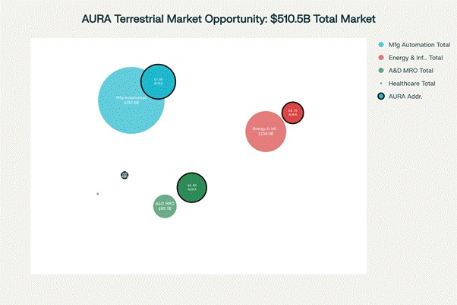

Figure : Market opportunity visualization showing AURA's addressable segments within major terrestrial markets

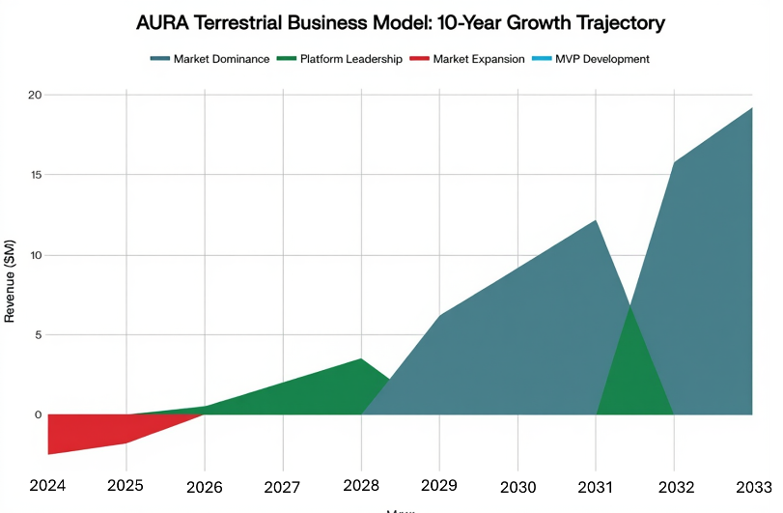

Figure : Revenue and investment progression showing AURA's path from healthcare pilots to market dominance

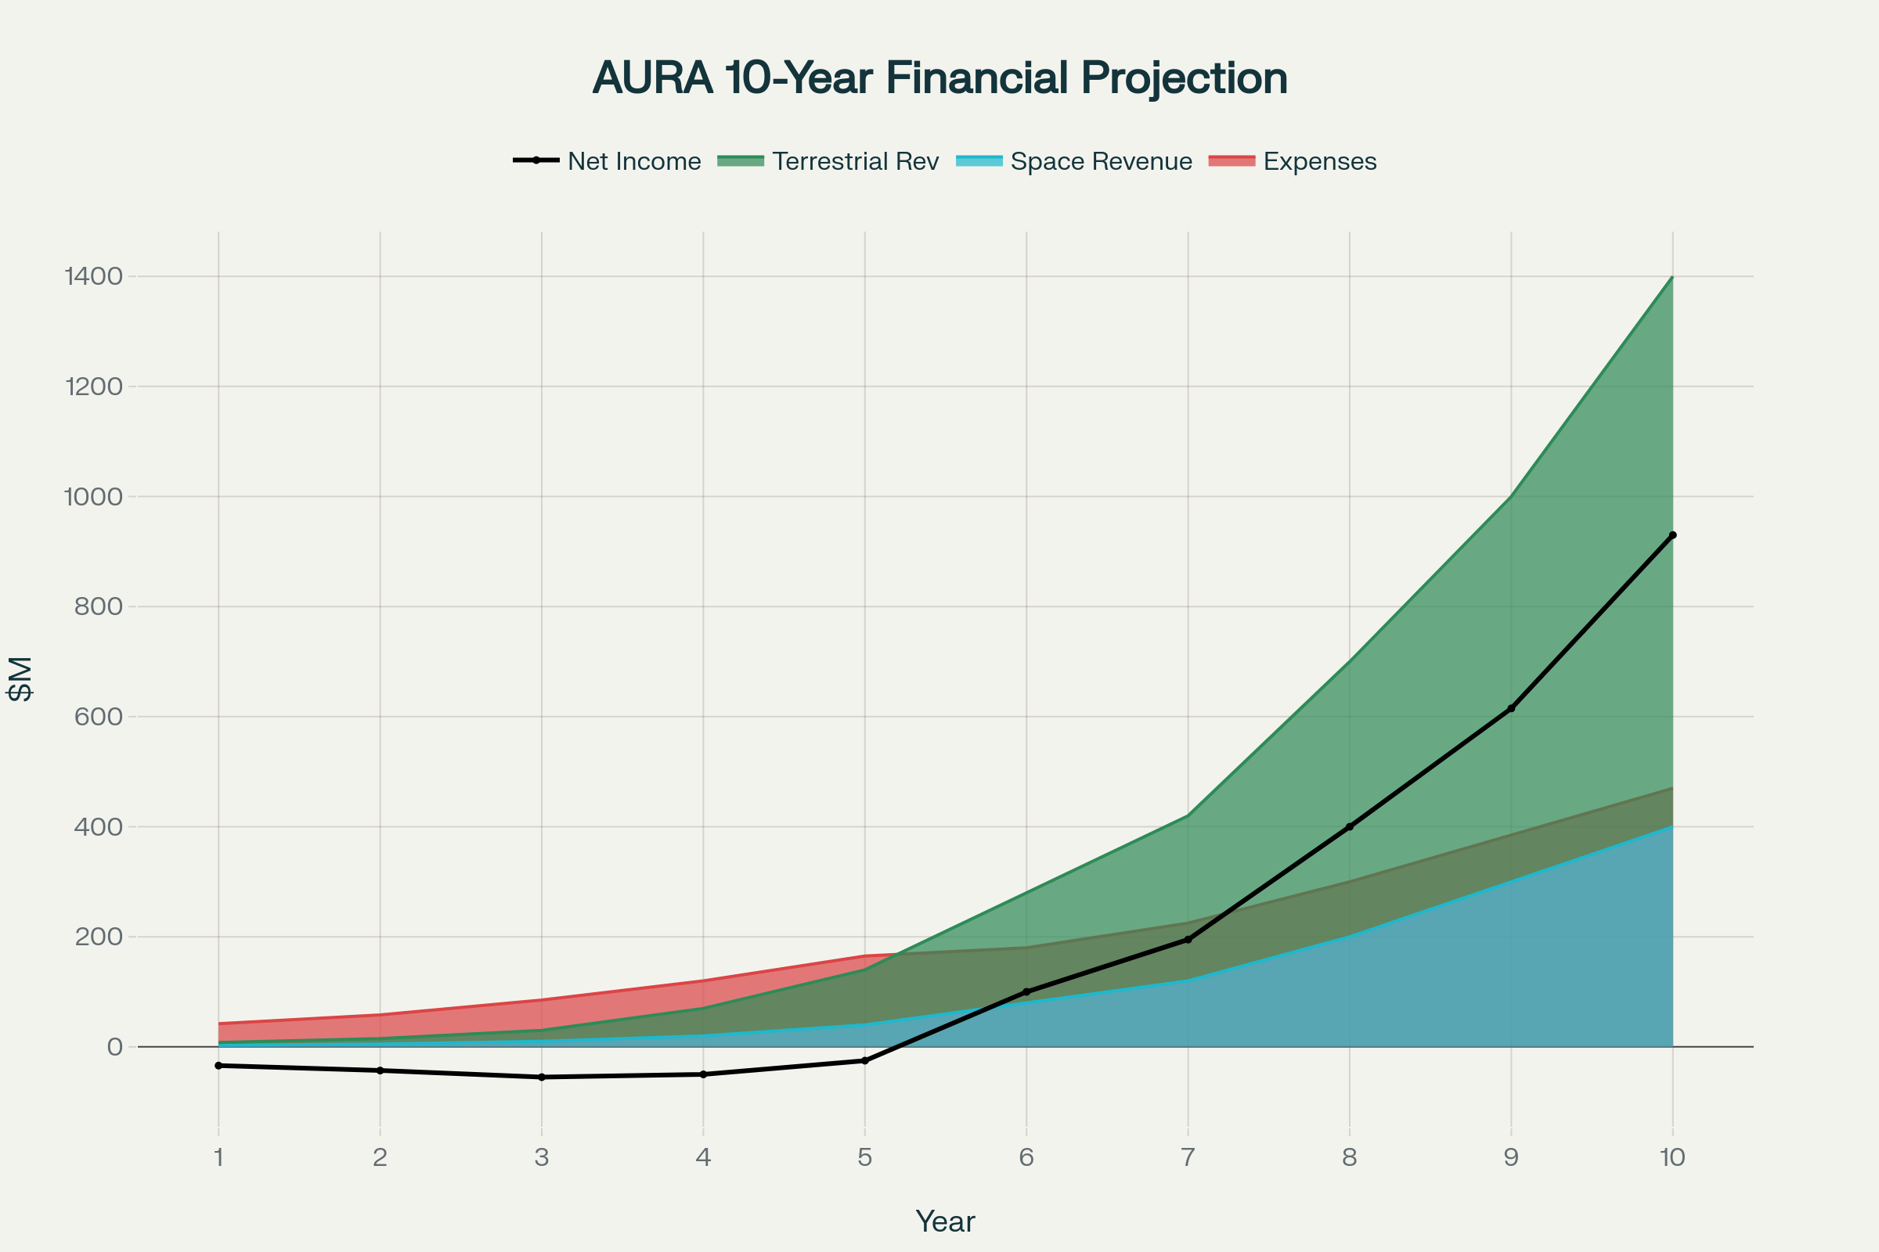

Figure : AURA's Space and Terrestrial Financial Projection (Breakdown in Appendix 6)

* **Terrestrial Market Opportunity:** AURA's terrestrial applications represent a $15.44 billion TAM across several high-growth sectors, including Industrial Augmented Reality ($80.4B market), Manufacturing Automation ($252.6B spending), and Healthcare Surgical Systems ($11.19B market).

### 4.3.2 AURA's Core Technological Advantages

AURA's revolutionary capability stems from the integration of seven subsystems into a unified, sovereign AI ecosystem. Its value proposition is identical for both space and Earth: providing autonomous, intelligent support in high stakes, often disconnected environments.

Table : AURA's Integrated Technology Stack

|  |  |
| --- | --- |
| **Subsystem** | **Key Performance Metrics & Features** |
| **1. Sovereign AI Brain** | AMD XQR Versal AI Core running fine-tuned Mistral 7B. 97.5% criticality rating accuracy & 182ms inference latency with a secure air-gapped architecture. |
| **2. N8N Workflow Orchestration** | Provides self-contained security, an intuitive visual workflow builder for astronaut/technician debugging, and seamless human-in-the-loop integration. |
| **3. Real-Time Biometric Support** | Transforms passive monitoring into active life support, enabling AI-driven emergency protocols based on real-time physiological data (e.g., hypoxia detection). |
| **4. AR/XR Visual Interface** | Delivers real-time procedural guidance, interactive task mapping, and adaptive information curation directly onto the user's field of view. |
| **5. Multi-Modal Sensor Fusion** | 12-camera RGB-D arrays, LiDAR, and full 9-DoF IMUs provide comprehensive environmental and user state awareness. |
| **6. ACE Generative Engineering** | On-demand fabrication of components from space-qualified PEEK thermoplastics and in-situ resources like regolith. |
| **7. VPK Kinematic Modeling** | Embodied AI understanding of user movement, capabilities, and physical limitations for ergonomic risk prevention and enhanced guidance. |

AURA's unique capability stems from integrating seven subsystems into a unified, sovereign AI ecosystem. Its value proposition is identical for both space and Earth: providing autonomous, intelligent support in high stakes, often disconnected environments.

|  |  |
| --- | --- |
| **Subsystem** | **Key Performance Metrics & Features** |
| **1. Sovereign AI Brain** | AMD XQR Versal AI Core running fine-tuned Mistral 7B. 97.5% criticality rating accuracy & 182ms inference latency with a secure air-gapped architecture. |
| **2. N8N Workflow Orchestration** | Provides self-contained security, an intuitive visual workflow builder for user debugging, and seamless human-in-the-loop integration. |
| **3. Real-Time Biometric Support** | Transforms passive monitoring into active life support, enabling AI-driven emergency protocols based on real-time physiological data. |
| **4. AR/XR Visual Interface** | Delivers real-time procedural guidance, interactive task mapping, and adaptive information curation directly onto the user's field of view. |
| **5. Multi-Modal Sensor Fusion** | 12-camera RGB-D arrays, LiDAR, and full 9-DoF IMUs provide comprehensive environmental and user state awareness. |
| **6. ACE Generative Engineering** | On-demand fabrication of components from space-qualified PEEK thermoplastics and in-situ resources like regolith. |
| **7. VPK Kinematic Modelling** | Embodied AI understanding of user movement, capabilities, and physical limitations for ergonomic risk prevention and enhanced guidance. |

### 4.3.3 Phased Commercialization Strategy & Financial Projections

The 10-year strategy is designed to leverage the faster-moving terrestrial market to fund and validate the technology for the long-cycle space domain.

* **Phase 1: Terrestrial MVP & TRL Development (Years 1-2)**
  + **Focus:** Healthcare pilots, aerospace MRO partnerships, and foundational TRL development.
  + **Investment:** $15M (Terrestrial) + $25M (Space) = **$40M**
  + **Revenue:** $12M (Terrestrial) + $8M (Space) = **$20M**
* **Phase 2: Market Expansion & Flight Qualification (Years 3-4)**
  + **Focus:** Industrial automation expansion, space qualification, and ISS demonstrations.
  + **Investment:** $45M (Terrestrial) + $75M (Space) = **$120M**
  + **Revenue:** $85M (Terrestrial) + $45M (Space) = **$130M**
* **Phase 3: Platform Leadership & Artemis Integration (Years 5-7)**
  + **Focus:** SaaS dominance, AI enhancements, and initial Artemis lunar deployment.
  + **Investment:** $120M (Terrestrial) + $150M (Space) = **$270M**
  + **Revenue:** $320M (Terrestrial) + $180M (Space) = **$500M**
* **Phase 4: Market Dominance & Operational Scale (Years 8-10)**
  + **Focus:** Global expansion, technology licensing, and preparation for Mars missions.
  + **Investment:** $200M (Terrestrial) + $200M (Space) = **$400M**
  + **Revenue:** $750M (Terrestrial) + $400M (Space) = **$1.15B**
* **Total 10-Year Outlook:**
  + **Total Investment:** **$830 Million**
  + **Total Revenue:** **$1.8 Billion**
  + **Net ROI:** **117%**

### 4.3.4 Revenue Model Architecture

AURA will employ a multi-stream revenue model tailored to its different markets.

* **Space Revenue Streams:**
  + NASA Artemis Contracts: $50-100M per mission (primary driver).
  + Commercial Space Stations (Blue Origin, Axiom): $25-50M per station.
  + International Space Agencies (ESA, JAXA): $10-30M per agency.
  + ISS Technology Demonstrations: $5-15M per deployment.
* **Terrestrial Revenue Streams:**
  + Hardware-as-a-Service: $8k-$25k monthly recurring revenue per unit for industrial facilities.
  + Software Subscriptions (SaaS): $2k-$12k monthly per user for high-margin software access.
  + Implementation Services: $100k-$2M per large-scale enterprise deployment.
  + ACE Usage Licensing: $50-$500 per generative session for custom manufacturing.

### 4.3.5 Competitive Advantages

AURA's integrated, symbiotic platform creates a deeply defensible market position.

1. Only Integrated Human-AI Symbiosis Platform: No competitor offers a holistic system combining AI, AR, and real-time biometrics.
2. Sovereign AI Architecture: The air-gapped design is a critical differentiator for security-sensitive defence, healthcare, and industrial clients.
3. Biometric-Adaptive Interface: The ability to adjust the UI based on the user's physiological state is a unique and powerful safety feature.
4. N8N Workflow Transparency: Allowing end-users to debug and modify AI workflows is a unique feature that builds trust and adaptability.
5. ACE Generative Engineering: Moves beyond procedural guidance to offer revolutionary, on-demand creative problem-solving.

In comparison to other companies:

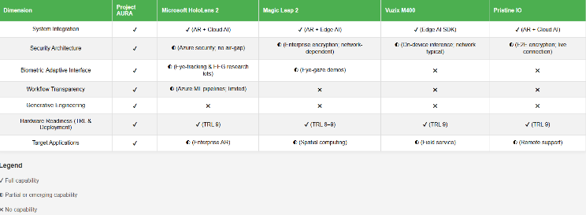

Figure : Market Analysis (Detailed analysis in Appendix XXX: Detailed Market Analysis)

## 4.4 Go-to-Market Execution & Investment Requirements

### 4.4.1 Immediate Actions (6-12 months)

1. Complete the $73K proof-of-concept to validate core functionality.
2. Secure NASA SBIR Phase I funding ($256K) to support early R&D.
3. Demonstrate the integrated AI + AR system at NASA centers to build stakeholder support.
4. Establish partnerships with Artemis prime contractors (e.g., Lockheed Martin, Boeing).

### 4.4.2 Investment Requirements

* **Seed Round ($3-8M):** To complete healthcare pilots, begin the FDA regulatory pathway, and expand the core team.
* **Series A ($20-35M):** To fund industrial expansion, achieve FDA clearance, and build out the sales team to reach $10M ARR.
* **Series B ($60-100M):** To develop the full SaaS platform, expand globally, and achieve 50+ major deployments.
* **Growth Capital ($150-300M):** To achieve market dominance, pursue strategic acquisitions, and solidify AURA as an industry standard.

## 4.5 Conclusion

The business opportunity is substantial, with a clear and executable strategy to capture a significant share of both the $1.15 billion space market and the $15.44 billion terrestrial market. Our integrated technology approach, combined with a first-mover advantage and space-heritage credibility, creates a defensible and highly scalable business model that will establish AURA as the essential platform for the future of human-AI collaboration.

Table : AURA vs. The State-of-the-Art.

|  |  |  |
| --- | --- | --- |
| Feature / Capability | Current ISS Operations (State-of-the-Art) | Project AURA |
| **Information Access & Procedural Guidance** | Static PDF documents on tablets; voice communication with ground control. Requires divided attention and is subject to communication latency. | **Integrated & Interactive:** Information is overlaid directly onto the physical environment via AR. Guidance is dynamic, hands-free, voice-controlled, and immediate, with built-in pathfinding. |
| **Situational Awareness** | Relies on astronaut's direct observation, voice reports from crewmates, and telemetry data relayed from ground control. | **Augmented & Fused:** AI fuses data from multiple sensors (visual, thermal, telemetry) to provide a comprehensive overlay of the environment, highlighting non-obvious information. |
| **Problem Solving & Repair** | Rely on ground support via high-latency comms for novel problems. Limited to on-hand spare parts. | **Onboard & Generative:** The ACE Module enables on-demand, generative design and in-situ fabrication of novel components to solve unforeseen hardware failures autonomously. |
| **Data Security & System Resilience** | Data transmitted to and from ground, subject to interception or communication link failure. System functionality is Earth-dependent. | **Sovereign & Resilient:** All processing is local, creating a "cognitive airgap" with total data sovereignty. System is fully functional without any external network connection. |
| **Human State Monitoring** | Periodic or separate health monitoring systems. Data is analysed on the ground, with feedback subject to latency. | **Real-Time & Closed-Loop:** Continuous biometric monitoring is integrated into the control loop. The AI proactively adapts the interface and makes recommendations based on the astronaut's real-time physiological and cognitive state. |

# 5.0 Conclusion: A New Symbiosis for Human Exploration

Project AURA represents a fundamental rethinking of the relationship between the human explorer and the tools that support them. Faced with the immutable reality of communication latency in deep space, the traditional model of Earth-based mission control becomes obsolete. AURA addresses this challenge not by merely creating a more sophisticated onboard manual, but by architecting a true human-AI symbiote.

The key innovations presented, the sovereign AI brain with its locally orchestrated, domain-expert agents, the interactive AR guidance system that transforms the physical environment into an intelligent, responsive workspace, and the Adaptive Contingency Engineering module that provides an unprecedented capability for in-situ problem-solving, are powerful in isolation. However, it is their seamless synthesis into a single, closed-loop ecosystem that marks a paradigm shift. This system empowers the astronaut with the collective knowledge of an entire ground team, the perceptual acuity of advanced sensors, and the creative capacity of generative AI, all delivered with zero latency and absolute security.

By offloading cognitive burdens, augmenting sensory perception, and enabling solutions to previously unsolvable problems, AURA allows the astronaut to transcend the role of a systems operator constantly battling complexity and environmental stress. It frees them to become what they are meant to be: scientists, engineers, and explorers, focused on the mission of discovery. AURA is more than an assistant; it is a force multiplier for human capability, ensuring that as humanity ventures farther from Earth, its capacity for ingenuity, resilience, and success travels with it. The development and deployment of this system will be a critical enabler for the next generation of human exploration, making sustained presence on the Moon, Mars, and beyond not just possible, but safe and productive.



# 6.0 References

|  |  |
| --- | --- |
| [1] | The European Space Agency, “Enabling effective communication for human space exploration beyond Low Earth Orbit,” [Online]. Available: https://nebula.esa.int/4000136202. |
| [2] | New Space Economy, “Communication Delays: The Hidden Challenge of Space Exploration,” [Online]. Available: https://newspaceeconomy.ca/2024/02/26/communication-delays-the-hidden-challenge-of-space-exploration/. |
| [3] | B. Joe, “Spaceflight associated neuro-ocular syndrome: connections with terrestrial eye and brain disorders,” 2024. [Online]. Available: https://doi.org/10.3389/fopht.2024.1487992. |
| [4] | A. G. Lee, T. H. Mader, C. R. Gibson, W. Tarver, P. Rabiei, R. F. Riascos, L. A. Galdamez and T. Brunstetter, “Spaceflight associated neuro-ocular syndrome (SANS) and the neuro-ophthalmologic effects of microgravity: a review and an update,” 2020. [Online]. Available: https://doi.org/10.1038/s41526-020-0097-9. |
| [5] | S. I. Dev, A. M. Khader, S. R. Begerowski, S. R. Anderson, G. Clément and S. T. Bell, “Cognitive performance in ISS astronauts on 6-month low earth orbit missions,” 2024. [Online]. Available: https://doi.org/10.3389/fphys.2024.1451269. |
| [6] | L. Bensch, T. Nilsson, J. Wulkop, P. Demedeiros, N. D. Herzberger, M. Preutenborbeck, A. Gerndt, F. Flemisch, F. Dufresne, G. Albuquerque and A. Cowley, “Designing for Human Operations on the Moon: Challenges and Opportunities of Navigational HUD Interfaces,” 2024. [Online]. Available: https://doi.org/10.1145/3613904.3642859. |
| [7] | N. McHenry, L. Davis, I. G. III, N. Coute, N. Roehrs, C. Villagran, G. E. Chamitoff and A. Diaz-Artiles, “Design of an AR Visor Display System for Extravehicular Activity Operations,” [Online]. Available: https://bhp.engr.tamu.edu/wp-content/uploads/sites/212/2021/03/McHenry-2020-Design-of-an-Augmented-Reality-Visor-Display-System-for-Extravehicular-Activity-Operations.pdf. |
| [8] | National Aeronautics and Space Administration, “EXPLORATION EVA SYSTEM CONCEPT OF OPERATIONS,” 2020. [Online]. Available: https://www.nasa.gov/wp-content/uploads/2017/02/eva-exp-0042_xeva_system_con_ops_rev_b_final_dtd_10192020_ref_doc.pdf. |
| [9] | J. Cho and B. Lee, “Optimal layout of four anchors to improve accuracy of Ultra-Wide band based indoor positioning,” 2024. [Online]. Available: https://doi.org/10.1016/j.eswa.2024.124808. |
| [10] | L. Yao, L. Yao and Y.-W. Wu, “Analysis and Improvement of Indoor Positioning Accuracy for UWB Sensors,” 2021. [Online]. Available: https://doi.org/10.3390/s21175731. |
| [11] | Ray-Ban Meta, “Meta Ray-Ban Display Glasses are HERE! 10 Features You Need to Know,” 2025. [Online]. Available: https://www.youtube.com/watch?v=X4T1r4lv7DY. |
| [12] | N. Kanas, “The Earth-Disconnect Phenomenon as a Psychological Stressor for Martian Crewmembers.,” Aerosp Med Hum Perform, 2025. [Online]. Available: https://pubmed.ncbi.nlm.nih.gov/40643386/. |
| [13] | J.-H. Youn, S.-Y. Jang, I. Hwang, Q. Pei, S. Yun and K.-U. Kyung, “Skin-attached haptic patch for versatile and augmented tactile interaction,” Sci Adv, 2025. [Online]. Available: https://pubmed.ncbi.nlm.nih.gov/40106556/. |
| [14] | Q. Fuxa, “WhisperLiveKit,” GitHub, 2025. [Online]. Available: https://github.com/QuentinFuxa/WhisperLiveKit?tab=readme-ov-file. |
| [15] | Center for Space Medicine, “How the Human Body Changes in Space,” Baylor College of Medicine, [Online]. Available: https://www.bcm.edu/academic-centers/space-medicine/translational-research-institute/space-health-resources/how-the-body-changes-in-space. |
| [16] | R. Baran, M. Wehland, H. Schulz, M. Heer, M. Infanger and D. Grimm, “Microgravity-Related Changes in Bone Density and Treatment Options: A Systematic Review,” International journal of molecular sciences, 2022. [Online]. Available: https://pmc.ncbi.nlm.nih.gov/articles/PMC9369243/. |
| [17] | O. J. J. IV, E. G. Buettmann, M. A. Friedman, R. C. DeNapoli, G. A. Hoppock and H. J. Donahue, “Update on the effects of microgravity on the musculoskeletal system,” npj Microgravity, 2021. [Online]. Available: https://doi.org/10.1038/s41526-021-00158-4. |
| [18] | L. J. Beckett, P. M. Williams, L. S. Toh, V. Hessel, L. Gerstweiler, I. Fisk, L. Toronjo-Urquiza and V. M. Chauhan, “Advancing insights into microgravity induced muscle changes using Caenorhabditis elegans as a model organism,” npj Microgravity, 2024. [Online]. Available: https://doi.org/10.1038/s41526-024-00418-z. |
| [19] | R. Bonanni, I. Cariati, M. Marini, U. Tarantino and V. Tancredi, “Microgravity and Musculoskeletal Health: What Strategies Should Be Used for a Great Challenge?,” Life (Basel, Switzerland), 2023. [Online]. Available: https://doi.org/10.3390/life13071423. |
| [20] | T. Russomano, M. da Rosa and M. A. dos Santos, “Space motion sickness: A common neurovestibular dysfunction in microgravity,” Neurology India, 2019. [Online]. Available: https://journals.lww.com/neur/fulltext/2019/67002/space_motion_sickness__a_common_neurovestibular.22.aspx. |
| [21] | NASA, “What Is Spaceflight Associated Neuro-ocular Syndrome?,” 2021. [Online]. Available: https://www.nasa.gov/image-article/what-spaceflight-associated-neuro-ocular-syndrome/. |
| [22] | J. Hicks, M. Olson, C. Mitchell, C. M. Juran and A. M. Paul, “The Impact of Microgravity on Immunological States,” ImmunoHorizons, 2023. [Online]. Available: https://doi.org/10.4049/immunohorizons.2200063. |
| [23] | H. Lv, H. Yang, C. Jiang, J. Shi, R.-a. Chen, Q. Huang and D. Shao, “Microgravity and immune cells,” Journal of the Royal Society, 2023. [Online]. Available: https://doi.org/10.1098/rsif.2022.0869. |
| [24] | A. MacQuarrie, M. Stainer, J. Sidhu and C. Deetlefs, “Wearable physiologic monitoring in healthcare simulation,” International Journal of Healthcare Simulation, 2023. [Online]. Available: https://doi.org/10.54531/polx6384. |
| [25] | Hexoskin, “Hexoskin wins contract to bring Astroskin sensors to the Moon,” 2024. [Online]. Available: https://hexoskin.com/blogs/news/hexoskin-wins-contract-to-bring-astroskin-sensors-to-the-moon?srsltid=AfmBOoqDfQx7DJs0EtFf1keCbXbmf5FmyIX8UorHZso_QCwySqZzga4s. |
| [26] | Hexoskin, “Astroskin: vital signs monitoring platform for advanced research,” [Online]. Available: https://hexoskin.com/pages/astroskin-vital-signs-monitoring-platform-for-advanced-research. |
| [27] | Z. Avsec and N. Latysheva, “AlphaGenome: AI for better understanding the genome,” Google DeepMind, 2025. [Online]. Available: https://deepmind.google/discover/blog/alphagenome-ai-for-better-understanding-the-genome/. |
| [28] | A. Regaladoarchive, “Google’s new AI will help researchers understand how our genes work,” MIT Technology Review, 2025. [Online]. Available: https://www.technologyreview.com/2025/06/25/1119345/google-deepmind-alphagenome-ai/. |
| [29] | D. E. Béchard, “DeepMind’s AlphaGenome Aims to Decode DNA’s ‘Dark Matter’,” Scientific American, 2025. [Online]. Available: https://www.scientificamerican.com/article/deepminds-alphagenome-uses-ai-to-decipher-noncoding-dna-for-research/. |
| [30] | A. M. Borg and J. E. Baker, “Contemporary biomedical engineering perspective on volitional evolution for human radiotolerance enhancement beyond low-earth orbit,” Synthetic biology, 2021. [Online]. Available: https://doi.org/10.1093/synbio/ysab023. |
| [31] | L. Zhao, Z. Li, B. Huang, D. Mi, D. Xu and Y. Sun, “Integrating evolutionarily conserved mechanism of response to radiation for exploring novel Caenorhabditis elegans radiation-responsive genes for estimation of radiation dose associated with spaceflight,” Chemosphere, 2024. [Online]. Available: https://doi.org/10.1016/j.chemosphere.2024.141148. |
| [32] | A. M. Borg and J. E. Baker, “Contemporary biomedical engineering perspective on volitional evolution for human radiotolerance enhancement beyond low-earth orbit,” Synthetic biology, 2021. [Online]. Available: https://doi.org/10.1093/synbio/ysab023. |
| [33] | US Department of State, “Treaty on Principles Governing the Activities of States in the Exploration and Use of Outer Space, Including the Moon and Other Celestial Bodies,” Bureau of Arms Control, Verification, and Compliance, 1967. [Online]. Available: https://2009-2017.state.gov/t/isn/5181.htm. |
| [34] | FEDERAL COURT OF AUSTRALIA, “Thaler v Commissioner of Patents [2021] FCA 879,” 2021. [Online]. Available: https://www.austlii.edu.au/cgi-bin/viewdoc/au/cases/cth/FCA/2021/879.html. |
| [35] | S. Karagiannakos, “How Neural Radiance Fields (NeRF) and Instant Neural Graphics Primitives work,” AI Summer, 2022. [Online]. Available: https://theaisummer.com/nerf/. |
| [36] | Dung3onlord, “This is how you can capture and reexperience memories in 3D,” Reddit r/virtual_reality, 2024. [Online]. Available: https://www.reddit.com/r/virtualreality/comments/1e4v29j/this_is_how_you_can_capture_and_reexperience/. |

# 7.0 Appendices

### Appendix 1: AURA Website

An overall view of AURA: <https://github.com/DSeahYS/18th-International-Space-Challenge/tree/main/SpaceWebsite>

### Appendix 2: Biometric Simulator Website

A full functionality backend simulator of the biometric portion: <https://github.com/DSeahYS/18th-International-Space-Challenge/tree/main/Astroskin>

### Appendix 3: Live Translation Demonstrator

Functional auto translation prototype: <https://github.com/DSeahYS/18th-International-Space-Challenge/tree/main/WhisperLiveKit>

### Appendix 4: In Depth Flow Chart

### Appendix 5: Properties and Applications of Mined In-Situ Materials

|  |  |  |  |  |  |
| --- | --- | --- | --- | --- | --- |
| Material | Source / Purity | Key Physical Properties | Key Performance Metrics | Primary ACE Applications | Broader Infrastructure Uses |
| Silicon (Si) | From silicate minerals in regolith via MRE. Purified to >99.999% with solar zone refining. | Density: 2.33 g/cm³  Melting Point: 1,414°C  Crystal Structure: Diamond cubic lattice. | Solar Cell Efficiency: 22-26% conversion  Radiation Resistance: Superior to terrestrial cells due to vacuum processing. | Custom-sized solar cells for tools or small rovers; Replacement photovoltaic wafers for suit power systems. | Solar Arrays: Foundation for gigawatt-scale lunar power grids; Powering habitats, rovers, and industrial processes. |
| Oxygen (O₂) | By-product of MRE, constituting 42-45% of regolith by weight | Purity: >99.5%  State: Cryogenic Liquid  Density (Liquid): 1.141 g/cm³  Boiling Point: -183°C. | Extraction Yield: 40-45 kg of O₂ per 100 kg of regolith  Specific Impulse (with LH₂): 450+ seconds. | Small, high-pressure oxygen canisters for emergency life support; Oxidiser for small chemical thrusters or cutting torches. | Life Support: Providing breathable atmosphere for habitats.  Rocket Propellant: The single greatest mass component of propellant, enabling refuelling on the Moon. |
| Iron (Fe) | From Ilmenite, Pyroxene, and Olivine minerals in regolith (up to 20% in mare regions). | Purity: Up to 95% recovery from MRE [C].  Density: 7.87 g/cm³  Melting Point: 1,538°C. | Tensile Strength: 350-900 MPa (as lunar steel alloy).  Hardness: 150-400 HB Brinell. | Brackets, fasteners, and structural supports; Simple hand tools (e.g., wrenches, hammers); Replacement mechanical parts for rovers. | Construction: Creating "lunar steel" for habitat frameworks, pressure vessels, and landing pads; Radiation shielding. |
| Aluminium (Al) | From Plagioclase Feldspar (Anorthite), constituting 10-18% of highland regolith. | Purity: High purity achievable via MRE.  Density: 2.70 g/cm³  Melting Point: 660°C. | Strength-to-Weight Ratio: Superior to steel  Corrosion Resistance: Excellent in vacuum. | Lightweight casings for electronics; Antennae components; Heat sinks and thermal management parts. | Aerospace Structures: Fabricating fuel tanks, vehicle frames, and trusses.  Electrical Systems: Creating power transmission cables and wiring. |
| Titanium (Ti) | From Ilmenite (FeTiO₃), with concentrations up to 13% in some mare regions. | Recycled from scrap or extracted from high-yield Ilmenite deposits. | Strength: High strength-to-weight ratio.  Corrosion Resistance: Extremely high. | High-strength, lightweight components for high-stress applications; Medical implants. | Advanced Alloys: Creating high-performance materials for rocket engine components and advanced aerospace structures. |

### Appendix 6: Risk Assessment Matrix

|  |  |  |  |  |  |  |  |
| --- | --- | --- | --- | --- | --- | --- | --- |
|  | **Hazard/Threat Identification** | | | **Risk (Safety/Security/Dual Use) Evaluation** | | | |
| No | Work Activity | Hazard/Threat | Possible Accident / Ill-Health/Adverse Impact | Possible / Existing Risk Control  (list according to hierachy of risk controls) | Severity  (score of 1 to 5) | Likelihood (score of 1 to 5) | RPN (severity x likelihood) |
| 1 | AI Hallucination/Inaccuracy | Provision of incorrect procedural or diagnostic information | Catastrophic mission failure, loss of life, or equipment loss. | Use a highly curated, domain-specific dataset for fine-tuning to eliminate the root cause of irrelevant or incorrect data | 5 | 2 | 10 |
| 2 | Automation Complacency & Bias | Astronaut over-relies on AI, fails to cross-check data, or misses novel anomalies | Delayed or incorrect response to off-nominal situations. | Design the user interface to be explanatory, not just instructional | 1 | 4 | 4 |
| 3 | Legal & Regulatory Ambiguity | Denial of mission license or inability to patent AI-generated designs | Project cancellation or loss of commercial IP value | Engage with regulatory bodies to co-develop compliance pathways and licensing frameworks for autonomous systems | 3 | 3 | 9 |
| 4 | Cognitive Overload from AR Interface | AR display becomes a distraction rather than an aid | Increased human error, missed cues, and task failure | Rigorously test and validate the "Auto-Dashboarding" algorithms to ensure they effectively simplify the UI based on accurate context-awareness | 4 | 2 | 8 |
| 5 | Radiation-Induced AI Compute Failure | Silent Data Corruption or system crash during critical operation | Loss of AI support when needed | Use of radiation-hardened computing platforms instead of commercial-off-the-shelf (COTS) components | 4 | 3 | 12 |
| 6 | Biometric Data Misinterpretation | AI misdiagnoses astronaut state (e.g., stress vs. illness) | Inappropriate system response (e.g., simplifying UI during a medical emergency) | Allow astronauts to easily input self-reported status (e.g., "I am stressed" / "I feel ill") to provide ground truth for the AI and correct misdiagnoses | 4 | 2 | 8 |
| 7 | Hybrid Power System Failure | Insufficient power during peak AI demand | System shutdown during a critical task | Design the power system with a significant conservative margin above the calculated peak power demand | 5 | 2 | 10 |
| 8 | VPK-NJF Model Inaccuracy in Microgravity | Incorrect prediction of astronaut kinematics | Ergonomic guidance leads to injury or collision avoidance fails | Implement a continuous calibration cycle where the model is periodically retrained on mission data to adapt to changing astronaut physiology and suit wear. | 5 | 3 | 15 |
| 9 | Ethical Concerns with Genomic Integration (AlphaGenome) | Privacy breaches or misuse of predictive health data | Erosion of crew trust and morale, legal challenges | Develop and enforce a strict ethical framework and policy on genomic data ownership, access, and use before any integration is considered | 3 | 5 | 15 |
| 10 | TTAD Sensor Failure | Loss of crew positional awareness on minimap or inaccurate vital signs display | Inability to locate or assist a crewmate in distress during an emergency | Establish a baseline protocol for crew members to maintain visual or tether contact as a primary method, using TTAD as a secondary aid. | 4 | 3 | 12 |
| 11 | Procedural Overlay Misalignment | AR guidance is incorrectly registered to physical hardware | Astronaut uses wrong tool, applies force to incorrect component, or damages equipment | Design a two-step verification where the astronaut must confirm the overlay alignment (e.g., "AURA, confirm bolt B14 is highlighted") before proceeding with a critical step. | 4 | 3 | 12 |
| 12 | "Object Identification" Misclassification | AI incorrectly identifies a system or component | Astronaut is given wrong information, leading to incorrect troubleshooting or operational decisions | Train astronauts on key system identifiers to maintain their own baseline knowledge | 3 | 3 | 9 |
| 13 | Cognitive Overload from Live Subtitling | AR display becomes cluttered with real-time text during complex multi-person dialogue | Astronaut misses critical visual cues or environmental hazards because they are reading text | Adaptive UI that minimizes other HUD elements or pauses subtitling during high-workload tasks unless specifically activated by the user. Allow for significant customization of subtitle appearance (size, transparency, position) to minimize obstruction of the central field of view. | 3 | 2 | 6 |
| 14 | Psychological Distress from AR-Mail | Overuse or emotionally jarring content in volumetric messages causes a decrease in crew morale or mental focus | Reduced operational performance and increased error rates | Provide user controls for the astronaut to easily schedule, pause, or disable AR-Mail playback during high-stress mission phases. | 2 | 2 | 4 |
| 15 | Translation System Jargon Failure | Real-time translation fails to accurately translate technical acronyms or specific engineering jargon | Miscommunication between crew members during a complex procedure | Pre-load a comprehensive, mission-specific technical dictionary into the translation model to ensure accuracy of key terms. | 3 | 1 | 3 |

### Appendix 7: Detailed Market Analysis

|  |  |  |  |  |  |
| --- | --- | --- | --- | --- | --- |
| Dimension | Project AURA | Microsoft (HoloLens) | Magic Leap (Magic Leap 2) | Vuzix (M400) | Pristine IO |
| System Integration | Fully integrated AI inference, AR visualization, real-time biometrics, haptics, and onboard manufacturing support. | AR headset + cloud AI services; biometric integration limited to third-party add-ons; no onboard generative tools. | AR headset focused on spatial computing and mixed reality; AI + biometrics via external cloud; no manufacturing module. | Lightweight AR glasses with edge AI SDK; no native biometric sensing or generative engineering. | Remote AR assistance platform pairing smart glasses with cloud-based video support; no local AI or biometric processing. |
| Security Architecture | Air-gapped sovereign AI Brain with cryptographically signed software updates, for defense-grade isolation. | Relies on Microsoft Azure security; continuous network connectivity required; not air-gapped. | Cloud-connected with enterprise encryption; network-dependent; no air-gap mode. | Edge-compute SDK supports on-device inference but typically connected; no air-gap guarantee. | Fully cloud-based video relay; end-to-end encryption but requires live connection. |
| Biometric-Adaptive Interface | Real-time physiological monitoring drives adaptive AR UI overlays and workflow pacing. | Experimental EEG and eye-tracking research kits; no production-grade adaptive UI. | Prototype biometric demos (e.g., eye-gaze); no commercial adaptive interface. | No built-in biometric sensing; third-party sensor integration only. | No biometric sensing; manual operator cues only. |
| Workflow Transparency | Built on n8n open workflow engine enabling end-user inspection, debugging, and modification of agent orchestration. | Closed proprietary pipelines; limited developer SDK hooks; no visual workflow editor. | Proprietary Lumin OS scripting; limited transparency; no low-code debugging tools. | Developer SDK but workflows embedded in app code; no visual orchestration UI. | Cloud workflow managed by Pristine platform; no user-accessible orchestration engine. |
| Generative Engineering | ACE module for on-demand component design, validation, and additive manufacturing using natural language. | No integrated generative design; separate Azure Design Studio (cloud-only) with limited physical fabrication linkage. | No generative engineering; focus on spatial UI rather than CAD. | No generative capabilities; only AR overlay guidance for manual tasks. | No generative tools; supports video annotations only. |
| Hardware Readiness (TRL & Deployment) | AI Core TRL 6-7; biometric TRL 9; AR TRL 5; ACE TRL 4; integrated prototype planned Q3 2026. | HoloLens 2 TRL 9; Azure services TRL 9; biometrics via third parties TRL 4-5. | Magic Leap 2 TRL 8; Lumin OS TRL 9; biometrics experimental TRL 3-4. | M400 TRL 9; edge AI SDK TRL 7; no biometric TRL. | Platform TRL 9; relies on commercially available smart glasses; no local AI. |
| Target Applications | Deep-space missions, defense field ops, remote industrial maintenance, medical surgery, disaster response. | Industrial AR, remote assistance, enterprise training, architecture, healthcare visualization. | Enterprise training, remote assistance, spatial computing for design and healthcare. | Field service, logistics, warehousing, manufacturing inspection. | Remote expert support in industrial maintenance and healthcare. |

### Appendix 8: Details for Gantt Chart

|  |  |  |  |  |  |  |
| --- | --- | --- | --- | --- | --- | --- |
| **Component/Feature** | **Task Name** | **Start (Date)** | **End (Date)** | **Duration (Days)** | **Priority** | **Percentage of Completion** |
| **PROJECT START - AURA Development Initiation** | | | | | | |
| AI Brain (AMD XQR Versal) | Design AI Brain Architecture (AMD XQR Versal) | 06/01/2025 | 20/02/2025 | 45 | High | 100% |
| ARXR Display Interface | Design ARXR Display Interface System | 06/01/2025 | 20/02/2025 | 45 | High | 100% |
| Haptic Feedback System | Design Haptic Feedback Patch System | 06/01/2025 | 05/02/2025 | 30 | High | 100% |
| Biometric Monitoring (Astroskin) | Design Biometric Monitoring Integration (Astroskin) | 06/01/2025 | 05/02/2025 | 30 | High | 100% |
| Power System (Betavoltaic + ESU) | Design Hybrid Power System (Betavoltaic + ESU) | 21/01/2025 | 22/03/2025 | 60 | Critical | 100% |
| ACE Module (Manufacturing) | Design ACE Module (Adaptive Contingency Engineering) | 05/02/2025 | 21/04/2025 | 75 | Medium | 100% |
| VPK System (Neural Jacobian) | Design VPK System (Neural Jacobian Fields) | 20/02/2025 | 21/05/2025 | 90 | Medium | 85% |
| n8n Workflow Orchestration | Design n8n Workflow Orchestration Framework | 26/01/2025 | 07/03/2025 | 40 | High | 100% |
| **MILESTONE: System Architecture & Design Complete - TRL 3-4 Achieved** | | | | | | |
| AI Brain (AMD XQR Versal) | Procure AMD XQR Versal AI Core Development Kit | 07/03/2025 | 06/04/2025 | 30 | Critical | 100% |
| ARXR Display Interface | Procure AR/XR Display Hardware | 07/03/2025 | 21/04/2025 | 45 | High | 100% |
| Haptic Feedback System | Procure Haptic Actuators & Vibrotactile Motors | 22/03/2025 | 21/04/2025 | 30 | High | 100% |
| Biometric Monitoring (Astroskin) | Procure Astroskin Biometric Monitoring System | 17/03/2025 | 06/04/2025 | 20 | Medium | 100% |
| Power System (Betavoltaic + ESU) | Develop Betavoltaic Power Prototype Unit | 06/04/2025 | 04/08/2025 | 120 | Critical | 75% |
| ACE Module (Manufacturing) | Develop Space-Grade PEEK Filament Supply | 21/04/2025 | 20/06/2025 | 60 | Medium | 80% |
| ACE Module (Manufacturing) | Procure 3D Scanning Equipment (LiDAR/Structured Light) | 06/05/2025 | 05/06/2025 | 30 | Medium | 90% |
| **MILESTONE: Component Procurement & Development Complete - TRL 4-5 Achieved** | | | | | | |
| AI Brain (AMD XQR Versal) | Fine-tune Mistral 7B LLM on Space Operations Dataset | 06/04/2025 | 21/05/2025 | 45 | Critical | 95% |
| AI Brain (AMD XQR Versal) | Develop Multi-Agent System (Procedural, Biometric, Systems, Navigation) | 21/04/2025 | 05/07/2025 | 75 | Critical | 80% |
| n8n Workflow Orchestration | Implement n8n Orchestration Framework | 06/05/2025 | 05/07/2025 | 60 | High | 85% |
| ARXR Display Interface | Develop AR Overlay Rendering Engine | 21/05/2025 | 19/08/2025 | 90 | High | 70% |
| Biometric Monitoring (Astroskin) | Implement Biometric Data Fusion Algorithms | 05/06/2025 | 20/07/2025 | 45 | High | 75% |
| ACE Module (Manufacturing) | Develop ACE Generative Design Pipeline | 20/06/2025 | 18/10/2025 | 120 | Medium | 60% |
| VPK System (Neural Jacobian) | Train VPK Neural Jacobian Field Models | 05/07/2025 | 18/10/2025 | 105 | Medium | 50% |
| Security & Infrastructure | Implement Security & Air-Gap Architecture | 20/07/2025 | 18/09/2025 | 60 | Critical | 40% |
| **MILESTONE: Software Development & AI Training Complete - TRL 5-6 Achieved** | | | | | | |
| System Integration | Integrate AI Brain with Hardware Platform | 04/08/2025 | 03/09/2025 | 30 | Critical | 30% |
| System Integration | Integrate ARXR Display with AI Brain | 19/08/2025 | 03/10/2025 | 45 | High | 20% |
| System Integration | Integrate Haptic Feedback System | 03/09/2025 | 03/10/2025 | 30 | High | 15% |
| System Integration | Integrate Biometric Monitoring System | 18/09/2025 | 18/10/2025 | 30 | High | 10% |
| System Integration | Integrate Power System (Betavoltaic + ESU) | 03/10/2025 | 17/11/2025 | 45 | Critical | 5% |
| Testing & Validation | Laboratory Testing - Closed Loop Operations | 18/10/2025 | 17/12/2025 | 60 | Critical | 0% |
| Testing & Validation | Performance Benchmarking & Optimization | 17/11/2025 | 01/01/2026 | 45 | High | 0% |
| **MILESTONE: System Integration & Laboratory Testing Complete - TRL 6-7 Achieved** | | | | | | |
| Environmental Testing | Thermal Vacuum Chamber Testing | 17/12/2025 | 16/01/2026 | 30 | Critical | 0% |
| Environmental Testing | Radiation Tolerance Testing (TID/SEE) | 01/01/2026 | 15/02/2026 | 45 | Critical | 0% |
| Environmental Testing | EMI/EMC Compatibility Testing | 16/01/2026 | 15/02/2026 | 30 | High | 0% |
| Environmental Testing | Vibration & Shock Testing | 31/01/2026 | 15/02/2026 | 15 | High | 0% |
| Analog Mission Testing | Underwater Analog Testing (NBL/Pool) | 15/02/2026 | 17/03/2026 | 30 | Medium | 0% |
| **MILESTONE: Environmental Testing & Validation Complete - TRL 7-8 Achieved** | | | | | | |
| Human Factors Testing | Develop Human Factors Testing Protocol | 02/03/2026 | 01/04/2026 | 30 | High | 0% |
| Human Factors Testing | Conduct EVA Simulation Testing | 17/03/2026 | 01/05/2026 | 45 | Critical | 0% |
| Analog Mission Testing | Desert Research Station (Mars Analog) Testing | 01/04/2026 | 31/05/2026 | 60 | High | 0% |
| Human Factors Testing | NASA-TLX Workload Assessment Studies | 01/05/2026 | 31/05/2026 | 30 | Medium | 0% |
| Human Factors Testing | Ergonomic Risk Assessment & Validation | 16/05/2026 | 15/06/2026 | 30 | Medium | 0% |
| **MILESTONE: Human Factors & Analog Mission Testing Complete** | | | | | | |
| Certification & Compliance | Prepare FAA Commercial Space Transportation Documentation | 31/05/2026 | 15/07/2026 | 45 | Critical | 0% |
| Certification & Compliance | NASA Safety Review & Certification Process | 15/06/2026 | 13/09/2026 | 90 | Critical | 0% |
| Flight Qualification | Space Qualification Testing (TRL 8-9) | 15/07/2026 | 13/09/2026 | 60 | Critical | 0% |
| Flight Qualification | Final System Integration & Acceptance Testing | 14/08/2026 | 28/09/2026 | 45 | Critical | 0% |
| Flight Qualification | Flight Readiness Review (FRR) | 13/09/2026 | 13/10/2026 | 30 | Critical | 0% |
| **MILESTONE: Flight Qualification & Certification Complete - TRL 9 Achieved** | | | | | | |
| Mission Operations | ISS Technology Demonstration Mission | 28/09/2026 | 27/03/2027 | 180 | Critical | 0% |
| Mission Operations | Artemis Lunar Mission Integration | 27/12/2026 | 27/12/2027 | 365 | High | 0% |
| Mission Operations | Deep Space Mission Deployment (Mars) | 06/01/2028 | 05/01/2030 | 730 | Medium | 0% |
| **MILESTONE: PROJECT COMPLETE - Mars Mission Operational** | | | | | | |

### Appendix 9: AURA's Space and Terrestrial Financial Projection

|  |  |  |  |  |  |
| --- | --- | --- | --- | --- | --- |
| Year | Operating Expenses ($M) | Space Revenue ($M) | Terrestrial Revenue ($M) | Total Revenue ($M) | Net Income ($M) |
| 1 | 42 | 3 | 5 | 8 | −34 |
| 2 | 58 | 5 | 10 | 15 | −43 |
| 3 | 85 | 10 | 20 | 30 | −55 |
| 4 | 120 | 20 | 50 | 70 | −50 |
| 5 | 165 | 40 | 100 | 140 | −25 |
| 6 | 180 | 80 | 200 | 280 | 100 |
| 7 | 225 | 120 | 300 | 420 | 195 |
| 8 | 300 | 200 | 500 | 700 | 400 |
| 9 | 385 | 300 | 700 | 1,000 | 615 |
| 10 | 470 | 400 | 1,000 | 1,400 | 930 |

* Total Revenue = Space Revenue + Terrestrial Revenue
* Net Income = Total Revenue − Operating Expenses

### Appendix 10: AURA Project Stakeholder Relationship Map

